Press release  October 2022 |  | Further information about publication:  Schüco International KG  Ulrike Krüger  Karolinenstr. 1–15  33609 Bielefeld, Germany  Tel.: +49 (0)521 783-803  Fax: +49 (0)521 783-950803  E-mail: PR@schueco.com  www.schueco.com/press  www.schueco.com/press

Individual design options:

WoodDesign for Schüco aluminium block windows

Bielefeld. The perfect combination of design, materials and functionality: the option of designing the inside of Schüco aluminium block window vents with a decorative wood strip is now available. This allows individual designs to be created to match the interior while providing the high performance values of an aluminium window. Schüco WoodDesign is available for the existing aluminium block window systems Schüco AWS 75 BS.HI+, AWS 75 BS.SI+ and AWS 90 BS.SI+.

Aluminium block windows impress with their excellent stability, durability and resistance properties. The special feature of the block window is the vent frame which is concealed by the outer frame. This means that the outer and vent frames do not visibly overlap.
The advantage of Schüco AWS (Aluminium Window System) WoodDesign is that the surface finish is different on the inside and outside. The inside of the vent is clad with a real wood strip. WoodDesign is a timber-look surface finish for the inside of aluminium profiles. The oakwood decorative strips are available in seven different versions: Pure, Natural, Walnut, Chocolate, Gris Beige, Savanna and Super White. Other surface finishes are available on request. Special handle versions have been developed to match the wood strips: a push-in handle with a rectangular rosette, a push-in handle with a round rosette and a standard handle with an oval rosette, which can be used to achieve burglar resistance up to RC 3. Depending on the design, the handles are available in the basic colours of black and white as well as a stainless steel look.
Procurement and fabrication of the wood kits
If the timber look is selected, the oakwood kit can be obtained from selected Schüco system partners (carpenters). What's great about it is that defined standards simplify the process for the Schüco partners. There is also the option of commissioning a timber fabricator of your own choice. The wood dimensions can be generated from SchüCal and made available. The decorative wood strips are applied to the cleaned aluminium block window profiles using special adhesive tape.

www.schueco.de/aws-wooddesign-en

Schüco – System solutions for windows, doors and façades
Based in Bielefeld, the Schüco Group develops and sells system solutions for windows, doors and façades. With 6330 employees worldwide, the company strives to be the industry leader in terms of technology and service both now and in the future. In addition to innovative products for residential and commercial buildings, the building envelope specialist offers consultation and digital solutions for all phases of a building project – from the initial idea through to design, fabrication and installation. Schüco works with 10,000 fabricators and 30,000 architectural practices, as well as construction professionals who commission buildings around the world. Founded in 1951, the company is now active in more than 80 countries and achieved a turnover of 1.995 billion euros in 2021. For more information, visit www.schueco.com

High resolution images are available to download in the Schüco Newsroom at www.schueco.com/press.

Picture credits: Schüco International KG
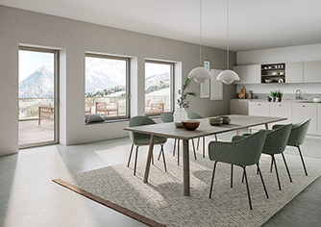
Aluminium outside, wood inside: with Schüco AWS WoodDesign, aluminium windows can be designed with a woodgrain finish on the inside (the oakwood version shown is Gris Beige).
Picture credits: Schüco International KG
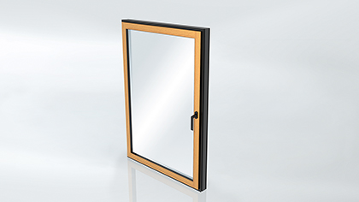
The oakwood decorative strips are applied to the inner side of the window profiles.

Picture credits: Schüco International KG
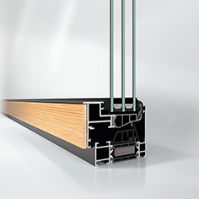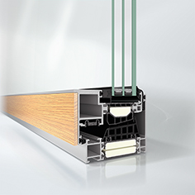
Schüco AWS (Aluminium Window System) WoodDesign is available for the existing aluminium block window systems Schüco AWS 75 BS.HI+, AWS 75 BS.SI+ (shown in left image) and AWS 90 BS.SI+ (shown in right image).

Picture credits: Schüco International KG
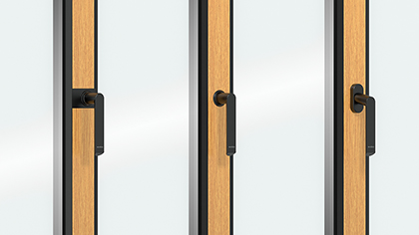
The range of handles for Schüco AWS WoodDesign includes push-in handles with a rectangular rosette, push-in handles with a round rosette and 43 mm standard handles with an oval rosette, all in the basic colours of black and white as well as a stainless steel look.

Picture credits: Schüco International KG
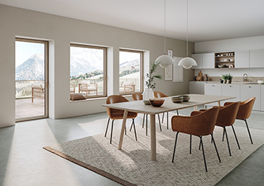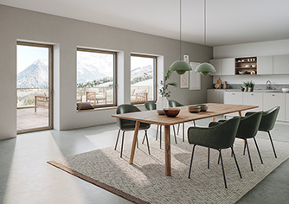
Schüco AWS WoodDesign is available in the following oakwood versions: Natural (shown in left image), Pure, Walnut (shown in right image), Chocolate, Gris Beige, Savanna and Super White. Other surface finishes are available on request.

