Press release  October 2022 |  | Further information about publication:  Schüco International KG  Ulrike Krüger  Karolinenstr. 1–15  33609 Bielefeld, Germany  Tel.: +49 (0)521 783-803  Fax: +49 (0)521 783-950803  E-mail: PR@schueco.com  www.schueco.de/presse  www.schueco.com/press

Schüco WoodDesign for aluminium windows

Aluminium outside, wood inside

Bielefeld. Wood is a timeless, homely and versatile natural material, making it very on-trend in interior design. In keeping with this high-quality design requirement, Schüco has combined both wood and aluminium in one window system. A woodgrain finish of your choice adds a design accent to the window profile on the inside and blends in harmoniously with the interior decor. Aluminium is used on the outside due to its excellent stability, durability and resistance properties. Schüco AWS (Aluminium Window System) WoodDesign is the perfect combination of design, materials and functionality.

The window vents and outer frames of Schüco aluminium block windows have form a visual whole, with the vent being almost completely concealed by the outer frame.
The advantage of WoodDesign is that the surface finishing is different on the inside and outside. This allows the high performance properties of aluminium windows to be utilised, while simultaneously providing individual design freedom indoors. Schüco AWS WoodDesign creates individual accents with oakwood and is available in seven versions: Pure, Natural, Walnut, Chocolate, Gris Beige, Savanna und Super White. Other surface finishes are available on request.

Range of handles
A handle design specifically developed for the wood finishes completes Schüco AWS WoodDesign and is available as a push-in handle with a rectangular rosette, a push-in handle with a round rosette and a standard handle with an oval rosette, which can also be used to achieve burglar resistance up to RC 3. Depending on the design, the handles are available in the basic colours of black and white as well as a stainless steel look.

Schüco WoodDesign is available for the aluminium block window systems Schüco AWS 75 BS.HI+ (75 mm basic depth, High Insulated), AWS 75 BS.SI+ (75 mm basic depth, Super Insulated) and AWS 90 BS.SI+ (90 mm basic depth, Super Insulated).

www.schueco.de/aws-wooddesign-en

Schüco – System solutions for windows, doors and façades
Based in Bielefeld, the Schüco Group develops and sells system solutions for windows, doors and façades. With 6330 employees worldwide, the company strives to be the industry leader in terms of technology and service both now and in the future. In addition to innovative products for residential and commercial buildings, the building envelope specialist offers consultation and digital solutions for all phases of a building project – from the initial idea through to design, fabrication and installation. Schüco works with 10,000 fabricators and 30,000 architectural practices, as well as construction professionals who commission buildings around the world. Founded in 1951, the company is now active in more than 80 countries and achieved a turnover of 1.995 billion euros in 2021. For more information, visit www.schueco.com

High resolution images are available to download in the Schüco Newsroom at
www.schueco.com/press.

Picture credits: Schüco International KG
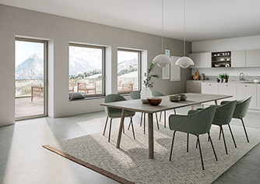
Aluminium outside, wood inside: with Schüco AWS WoodDesign, aluminium windows can be designed with a woodgrain finish on the inside (the oakwood version shown is Gris Beige).
Picture credits: Schüco International KG
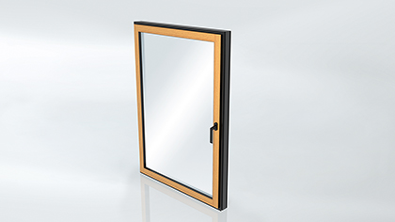
The oakwood decorative strips are applied to the inner side of the window profiles.

Picture credits: Schüco International KG
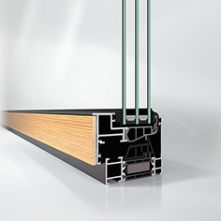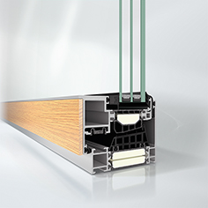
Schüco AWS (Aluminium Window System) WoodDesign is available for the existing aluminium block window systems Schüco AWS 75 BS.HI+, AWS 75 BS.SI+ (shown in left image) and AWS 90 BS.SI+ (shown in right image).

Picture credits: Schüco International KG
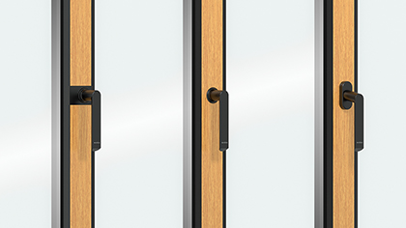
The range of handles for Schüco AWS WoodDesign includes push-in handles with a rectangular rosette, push-in handles with a round rosette and a window handle with an oval rosette, all in the basic colours of black and white as well as a stainless steel look.

Picture credits: Schüco International KG
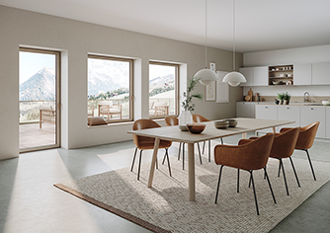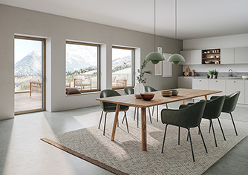
Schüco AWS WoodDesign available in the following oakwood versions: Natural (shown in left image), Pure, Walnut (shown in right image), Chocolate, Gris Beige, Savanna and Super White. Other surface finishes are available on request.

