Press release  September 2022 |  | Further information about publication:  Schüco International KG  Ulrike Krüger  Karolinenstr. 1–15  33609 Bielefeld, Germany  Tel.: +49 (0)521 783-803  Fax: +49 (0)521 783-950803  E-mail: PR@schueco.com  www.schueco.com/press  www.schueco.com/press

Passive house certification with Schüco AWS optimized

Improved U values for the standard aluminium system

Bielefeld. Saving energy is more important than ever right now. This is particularly true in the building industry, where advantage needs to be taken of potential energy savings. That is why Schüco is continually further developing it products. Under the name AWS optimized, the company is presenting its standard aluminium system to architects and metal fabricators but with even better U values – right up to passive house certification.

Improved thermal insulation by up to 20 percent – that's what sets the Schüco AWS optimized aluminium window systems with a 75 and 90 mm basic depth apart from the previous standard systems. A sophisticated system of tailored energy efficiency measures – such as a unique four-headed insulating bar optimized with foam in the vent, an improved insulating bar in the outer frame, a thermally perfected centre gasket and a special glazing rebate gasket – enables outstanding U values to be achieved with narrow face widths. The AWS 75.SI⁺ optimized profile construction achieves a U_{f} value as low as 0.94 W/(m²K), which means it is possible to manufacture long-lasting energy saving windows without requiring any additional resources. The constructions are certified by the Passive House Institute in Darmstadt from an external face width of 178 mm for the AWS 75.SI+ and 117 mm for the AWS 90.SI+.

For architects who want elegant window fronts to passive house level without the window vents being visible from the outside, Schüco also offers its AWS 75 BS.SI⁺ (75 mm basic depth) and AWS 90 BS.SI⁺ (90 mm basic depth) block window constructions in the Optimized version as well. With their narrow external profile face widths, both of these designs create bright living and working spaces that are flooded with light for stylish architecture that will stand the test of time.

Product Manager Stefan Hodapp summarises the motivation behind this development: “Windows are important components when it comes to achieving a good climate balance in buildings. With the Schüco Optimized technology, we have responded to market requirements and set a new thermal insulation standard for our aluminium systems.”

For more information, visit www.schueco.de/aws-optimized-en

Schüco – System solutions for windows, doors and façades
Based in Bielefeld, the Schüco Group develops and sells system solutions for windows, doors and façades. With 6330 employees worldwide, the company strives to be the industry leader in terms of technology and service both now and in the future. In addition to innovative products for residential and commercial buildings, the building envelope specialist offers consultation and digital solutions for all phases of a building project – from the initial idea through to design, fabrication and installation. Schüco works with 10,000 fabricators and 30,000 architectural practices, as well as construction professionals, who commission buildings around the world. Founded in 1951, the company is now active in more than 80 countries and achieved a turnover of 1.995 billion euros in 2021. For more information, visit www.schueco.com

High resolution images are available to download in the Schüco Newsroom at www.schueco.com/press.

Picture credits: Schüco International KG
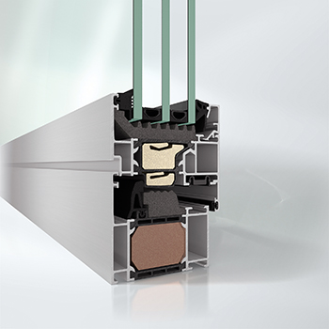
Schüco AWS 75.SI⁺ optimized with a 75 mm basic depth and a face width of 117 mm:
Thermal insulation to passive house level with a U_{f} value of 0.94 W/(m²K).

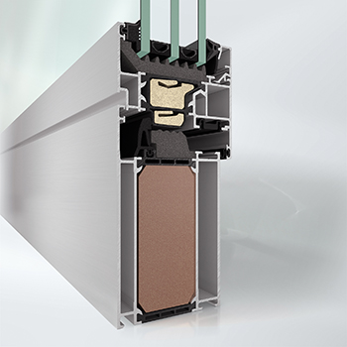
Schüco AWS 75.SI⁺ optimized with a 75 mm basic depth and a face width from 178 mm:
Passive house certified thermal insulation with a U_{f} value of 0.79 W/(m²K).

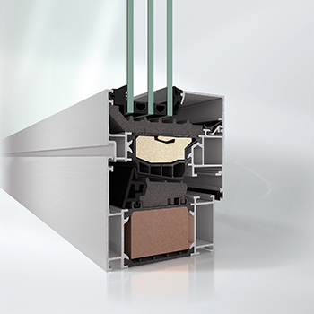
Schüco AWS 90.SI⁺ optimized with a 90 mm basic depth and an external face width from 117 mm:
Passive house certified thermal insulation with a U_{f} value of 0.80 W/(m²K).

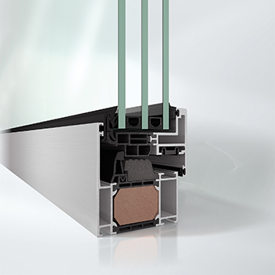
AWS 75 BS.SI⁺ block system with a 75 mm basic depth and a face width of 99 mm:
Thermal insulation with a U_{f} value of 1.2 W/(m²K).

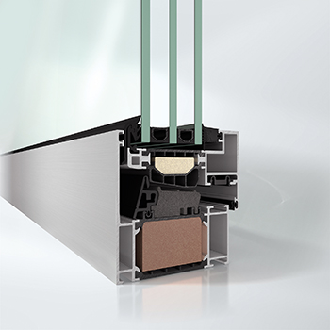
AWS 90 BS.SI⁺ optimized with a 90 mm basic depth and a face width of 99 mm:
Thermal insulation to passive house level with a U_{f} value of 1.0 W/(m²K).

