Press release  5. September 2022 |  | Further information about publication:  Schüco International KG  Ulrike Krüger  Karolinenstr. 1–15  33609 Bielefeld, Germany  Tel.: +49 (0)521 783-803  Fax: +49 (0)521 783-950803  E-mail: PR@schueco.com  www.schueco.de/presse  www.schueco.com/press

Working towards a closed PVC-U material cycle:

REMONDIS and Schüco enter into a strategic partnership

Weißenfels. REMONDIS and Schüco believe that more can be achieved by working together. Based on the idea that buildings are valuable raw material stores of the future, the two partners want to play an active role in satisfying the growing demand for resources, while also making a real contribution towards making the construction industry more sustainable with a closed PVC-U material cycle.

When it comes to sustainable construction, the longevity and recyclability of materials are essential properties. PVC-U windows, for example, have a service life of around 40 years. If the circular economy is working as it should, the PVC-U used in these windows can be recycled up to seven times without any significant loss of quality. This means that the material can be used as a building component for several hundred years. To ensure that PVC-U windows can be recycled following their active usage phase and the recyclable material is reused as often as possible, as a founding member of the Rewindo recycling initiative, for the last two decades Schüco has dedicated itself to establishing a functioning collection and return system for production waste from the manufacture of PVC-U profiles and windows, as well as old PVC-U windows from renovation projects.

In view of the company's sustainability goals, Schüco would now like to take this commitment even further. Subject to the relevant authorities assessing whether or not any competition law is breached, that's why REMONDIS Recycling GmbH & Co. KG and Schüco Polymer Technologies KG agreed to pool their expertise at the beginning of August 2022. In future, the plan is for RE:CORE GmbH to map out the PVC-U recycling process – with the aim of creating a closed PVC-U material cycle for Schüco and offering Schüco partner companies an exclusive recycling service for profile offcuts from window fabrication as well as old windows.

Markus Herbst, CEO of Schüco Polymer Technologies KG, is looking forward to the partnership: "At Schüco, we believe that a closed PVC-U material cycle is yet another strategic step towards establishing future-proof circular construction methods. A company like REMONDIS is the perfect match for our sustainability strategy." Ralf Mandelatz, Managing Director of REMONDIS Recycling GmbH & Co. KG, elaborates: "Both companies are united by their ambition to conserve raw materials worldwide and to reduce the climate and environmental damage caused by the extraction of primary raw materials. We are constantly working on developing new technologies and all of our thoughts are devoted to conserving resources."

REMONDIS Recycling GmbH & Co. KG, based in Essen, is a specialist in the processing of plastics and glass. The subsidiary, which is part of the REMONDIS Group, specialises in the management of complex material flows and any subsequent processing. The materials are processed correctly using state-of-the-art technology and fed back into the material cycle as high-quality recyclable raw materials. REMONDIS and Schüco want to join forces to accelerate the establishment of a European PVC-U material cycle for building components, further contributing to the conservation of resources as well as saving energy.

Schüco – System solutions for windows, doors and façades
Based in Bielefeld, the Schüco Group develops and sells system solutions for windows, doors and façades. With 6,330 employees worldwide, the company strives to be the industry leader in terms of technology and service both now and in the future. In addition to innovative products for residential and commercial buildings, the building envelope specialist offers consultation and digital solutions for all phases of a building project – from the initial idea through to design, fabrication and installation. Schüco works with 10,000 fabricators and 30,000 architectural practices, as well as construction professionals, who commission buildings around the world. Founded in 1951, the company is now active in more than 80 countries and achieved a turnover of 1.995 billion euros in 2021. For more information, visit www.schueco.com

High resolution images are available to download in the Schüco Newsroom at www.schueco.com/press

Photographer: REMONDIS Recycling GmbH & Co. KG
Usage rights: Schüco International KG
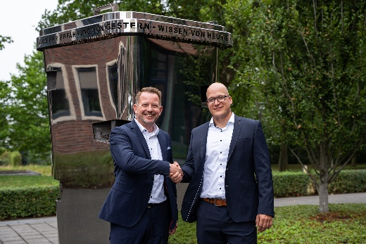
From the left: Mario Husemann from REMONDIS and Dirk Schneider from Schüco will be taking over the management of RE:CORE GmbH and are looking forward to working together.

Photographer: Philipp Kirschner, PK Fotografie
Usage rights: Schüco International KG
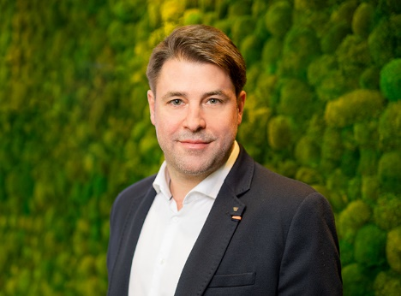
Markus Herbst, CEO of Schüco Polymer Technologies KG in Weißenfels.

Photographer: REMONDIS Recycling GmbH & Co. KG
Usage rights: Schüco International KG
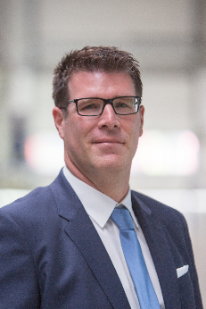
Ralf Mandelatz, Managing Director of REMONDIS Recycling GmbH & Co. KG.

