Press release  August 2022 |  | Further information about publication:  Schüco International KG  Ulrike Krüger  Karolinenstr. 1–15  33609 Bielefeld, Germany  Tel.: +49 (0)521 783-803  Fax: +49 (0)521 783-950803  E-mail: PR@schueco.com  www.schueco.de/presse  www.schueco.com/press

No more forgotten open windows

Schüco SensTrack wireless

Bielefeld. Summer is the time for leaving windows wide open or often tilted all day long, to allow a comfortable flow of air throughout the house. Storms and downpours are not uncommon at this time of year and burglars don't take the summer off either. Rising heating costs also mean that, in the colder months, break-ins are not the only worry for homeowners who accidentally leave a window open. That is why it is so important for homeowners to be informed about the locking status of their windows at all times, whether they are at home or out of the house. The Schüco SensTrack wireless energy self-sufficient monitoring of closing makes this possible. The concealed smart wireless sensor constantly monitors the locking status of the window, ensuring greater energy efficiency, security and control every day.

Schüco SensTrack wireless reliably transmits signals about the locking status of the window and can be directly connected to EnOcean-compatible systems or KNX systems by means of an additional external gateway. The wireless keep recognises when a window is open, for example, and reports this to networked thermostats via a smart home system or EnOcean sensors, providing smart added value in the colder months. Unnecessary heating while the home is being ventilated is therefore a thing of the past. Unlike standard systems for monitoring of closing on the market, Schüco SensTrack wireless does not require an external energy supply. The wireless sensor receives its energy from the movement of the fitting when the window is being locked and unlocked, allowing it to communicate wirelessly with an EnOcean-compatible smart home system. The wireless sensor requires no batteries or cables and is therefore energy self-sufficient and sustainable. No maintenance work is necessary as no batteries need to be used or changed. And even when the homeowner is out of the house, the smart sensor provides a feeling of security by allowing them to remotely check the locking status of their windows via the smart home app.

For newbuilds, renovations and retrofitting
Schüco SensTrack wireless is integrated in the fittings groove, so is almost completely concealed. It therefore does not impact on the appearance of the window. Furthermore, its concealed installation protects it from being tampered with from the outside. The wireless sensor can be directly installed or retrofitted in Schüco AWS aluminium window systems with AvanTec and AvanTec SimplySmart fittings.

More information is available at www.schueco.de/monitoring-senstrack-wireless

Schüco – System solutions for windows, doors and façades
Based in Bielefeld, the Schüco Group develops and sells system solutions for windows, doors and façades. With 6330 employees worldwide, the company strives to be the industry leader in terms of technology and service both now and in the future. In addition to innovative products for residential and commercial buildings, the building envelope specialist offers consultation and digital solutions for all phases of a building project – from the initial idea through to design, fabrication and installation. Schüco works with 10,000 fabricators and 30,000 architectural practices, as well as construction professionals, who commission buildings around the world. Founded in 1951, the company is now active in more than 80 countries and achieved a turnover of 1.995 billion euros in 2021. For more information, visit www.schueco.com

High resolution images are available to download in the Schüco Newsroom at www.schueco.com/press.

Picture credits: Schüco International KG
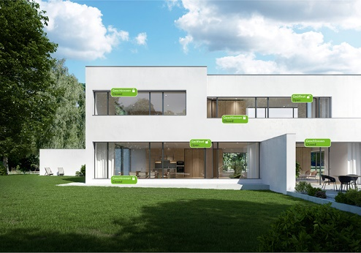
Secure, energy-efficient and smart: with Schüco SensTrack wireless, no windows are accidentally left open.

Picture credits: Schüco International KG
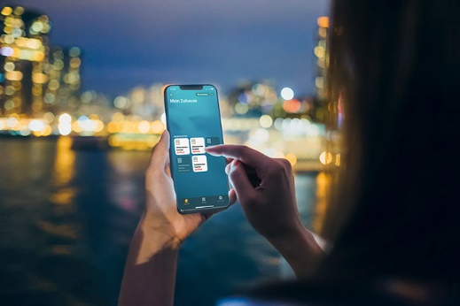
Whether at home or out and about, the locking status of the window can be checked via the smart home app.

Picture credits: Schüco International KG
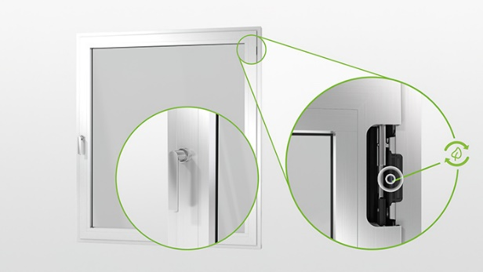
The energy self-sufficient monitoring of closing system requires no cables and can be easily retrofitted in the fittings groove of existing Schüco windows.

Picture credits: Schüco International KG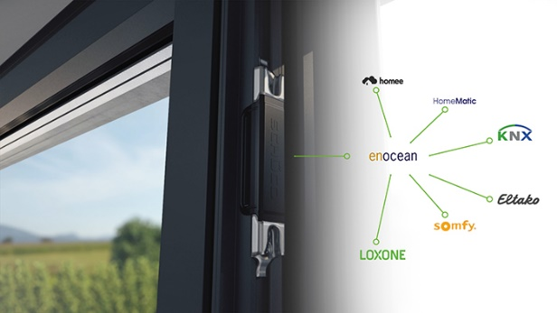
The wireless keep can be directly connected to EnOcean-compatible systems or KNX systems by means of an additional external gateway.

