Press release  July 2022 |  | Further information about publication:  Schüco International KG  Thomas Lauritzen  Karolinenstr. 1–15  33609 Bielefeld, Germany  Tel.: +49 (0)521 783-233  E-mail: tlauritzen@schueco.com  www.schueco.de/presse  www.schueco.com/press

2021 Schüco annual report

Turnover significantly higher than previous year

Bielefeld. The 2021 business year was also overshadowed by the Covid-19 pandemic. A global raw materials crisis with delivery bottlenecks and the resulting price increases led to huge challenges for all the players in the construction market. Despite this difficult global economic situation, the Schüco Group grew in its 70th year. Thanks to increased demand in important international core markets, the company was able to achieve a turnover of 1.995 billion EUR in the 2021 business year, which is 17.7% above the previous year's turnover (1.695 billion EUR). Schüco products and services are available in over 80 countries across the globe.

Taking the 2021 yearly average, the Schüco Group employs a total of 6330 members of staff. 3940 of those employees work in Germany, with 2355 in the region of East Westphalia-Lippe. At 87.5 million EUR, investments in 2021 were 62% above the previous year. More than 30 million EUR of this was pumped into the extensive building work at the headquarters that was started in 2016. The equity capital of the Schüco Group remains unchanged at around 70%.

- Acquisitions, joint ventures and new start-ups

1.1 Alufit International Private Ltd., Bangalore
The acquisition of a majority stake in the Indian company Alufit International Private Ltd. in Bangalore was completed on 1 November 2021. Alufit is India's leading façade fabricator and is renowned for its complex commercial buildings. This stake gives Schüco the opportunity to increase its growth in India through large façade projects in the commercial and infrastructure sectors too. In parallel, Schüco India Private Limited, which was founded 10 years ago, is concentrating on the system business and expanding the existing business model.

1.2 Schüco Japan K.K., Tokyo
As part of a new joint venture, LIXIL, a large local building material company, has had a stake in the Schüco Japan K.K. subsidiary since August 2021. The aim of this merger is to open up new opportunities in the market. The Japanese construction industry offers enormous potential for growth and German companies and products “Made in Germany” have a particularly good reputation there.

1.3 Schueco Vietnam Co. Ltd., Ho Chi Minh City
Schueco Vietnam Co. Ltd. was founded in Ho Chi Minh City in October 2021. The aim of the Schüco subsidiary is to expand sales activities in Vietnam, increase brand awareness and offer product training at their own training centre.

- Development of Metal business division

2.1 Global development
Despite great uncertainty in the respective procurement markets, the Metal (aluminium and steel) business division achieved a global turnover of 1.585 billion EUR, an increase in turnover of 13.6% compared to the previous year (1.395 billion EUR).

  - Sales regions outside Europe
Outside Europe, turnover was increased by 23.1% to 320 million EUR compared to the previous year (260 million EUR). However, the markets developed at different speeds during the second year of the coronavirus pandemic. In China, sales targets were exceeded (influenced by the exchange rate, among other things), while in India, the forecasted revenue was achieved. The subsidiary in Korea continued to deliver very positive results. The Russian company also again developed its market position further, as did the smaller sales regions such as Ukraine and Israel.

2.3 Sales regions within Europe
Within Europe, the Schüco Metal division was also able to increase turnover by 11.3% to 1.185 billion EUR compared to the previous year (1.065 billion EUR). This growth was also hindered by the tense supply situation around the world and the sharp increase in raw material prices. Denmark and the Baltic States fell short of expectations, whereas Italy, France, the UK, Iberia, Greece, Norway, the Czech Republic and the Benelux States demonstrated an upward trend and were able to grow their turnover compared to the previous year.

2.3.1 The sales region of Germany
In its home market, the Metal division exceeded the previous year's turnover (520 million EUR) by 7.3% with 558 million EUR. Although the construction sector could also be seen as a stabilising factor in German economic output in 2021, supply bottlenecks and price increases hampered growth. However, additional sales and pull-forward effects were able to re-balance the situation.

- Development of PVC-U business division
The pandemic, the materials crisis, unstable procurement markets, significant increases in procurement cost and high demand were also challenging conditions for the Schüco Polymer Technologies KG subsidiary, based in Weißenfels, Germany. It was not possible to fully utilise the available production and logistics capacities in part due to a lack of materials for production. Despite these difficulties, the business division still delivered a very positive performance in its European sales markets – above all in Germany, Italy, Benelux, France and Poland. Turnover of 389 million EUR was achieved in the 2021 business year – 38.9% above the previous year (280 million EUR).

In the core market of Germany, turnover of 143 million EUR was generated, which was 24.3% higher than the previous year (115 million EUR). Favourable financing conditions and sustained high demand in the residential sector stimulated growth here.

- Digital roadmap
In 2021, the company continued to pursue its aim of an almost complete digitalisation of all the processes in the construction industry, by networking everything from the design and planning of a building project right through to its fabrication, installation, use, maintenance and recycling. To do this, new products and services were developed and launched. For example, SchüCal MES (Manufacturing Execution System) is a fabrication control system that was developed for metal fabrication customers to create complete process transparency and to put customers in a position to be able to optimise their fabrication workflows and improve quality.

Schüco recognised the potential of digitalisation early on. For 50 years, the company has been shaping the digital transformation of the construction industry and now offers by far the largest portfolio of digital solutions in the industry, all from a single source. This ensures holistic networking, greater cost-effectiveness, reliability and convenience in the day-to-day work of planners and customers.

5. Motivation Green
For Schüco, sustainable action is about everyone being able to live well – in buildings and beyond, for generations to come. That is why the company aligns itself with the Sustainable Development Goals of the United Nations and uses its expertise and understanding of quality to contribute towards implementing them.

Going far beyond climate and environmental protection, Schüco sees sustainability as a concrete task with six defined action areas: environment, products, business development, supply chain, employees and society. As this cannot all be achieved at the same time, Schüco has set out six projects for these action areas to further narrow down the sustainability priorities and provide a clear focus. For example, the focus project for the environment action area is called “Emission Zero”, which specifically deals with the CO₂ reduction targets of the company. By 2025, Schüco wants to reduce its total emissions by 30% compared to the reference year of 2018 and to no longer generate any environmentally harmful carbon emissions at all by 2040. These targets were worked out together with WWF Germany and their effectiveness was confirmed by the Science Based Targets initiative (SBTi). The Schüco Sustainability Report published in 2021 provides more information about further issues and can be viewed at schueco.com/sustainability.

6. Industry campaign tackling the lack of skilled workers
The metal construction industry is lacking approximately 50,000 skilled workers and junior staff. This has real consequences. Windows, doors, façades, sliding systems and sun shading systems are essential elements of construction. That is why the company developed a comprehensive industry recruitment campaign at the end of 2021 for Schüco metal fabrication partners together with the agency YeaHR to target potential skilled workers and to show junior staff the path into the metal construction industry. The success of the campaign depends on the commitment of the entire industry – the more metal fabricators that take part, the greater the awareness will be in the public domain. Compared to individual campaigns, this will reach, inform and motivate more people to apply or to choose a career in metal fabrication. Those interested can find out all the important information about metal fabrication, careers in the industry and job vacancies at the companies taking part on the website: www.metallbaut-zukunft.com.

7. Product developments in Metal division
In 2021, the focus of the Metal business division was on the development of holistic solutions for the building envelope. In particular, the fusion of form and function were the focus here. Concepts and products for the seamless integration of sliding doors and windows in façade constructions were developed and can now be seen on the Schüco Campus or in the new Welcome Forum. Smart networking of the control of all of the components in a building envelope was another key area.

7.1 Façade systems in Metal division
In the field of façade systems, the UDC 80 (Unitized Dynamic Construction with an 80 mm profile face width) dynamic unitised façade platform was further enhanced and launched on the relevant markets. The Façades team responded to specific requirements for individual project solutions by creating special constructions and hybrid designs. For example, green façades were integrated into the product range as a project solution for inner city buildings. They offer a vast range of design options with a wide variety of plants and system structures.

7.2 Window systems in Metal division
The focus of product developments in the field of window systems for 2021 can be summarised with the words “creating added value”. This product area offered added value, for example, through a fitting which enables tilted aluminium windows to achieve RC 2 burglar resistance. Or with the AWS 90 AC.SI Schüco acoustic window (Aluminium Window System, 90 mm basic depth, Acoustics, Super Insulated), which combines sound reduction and natural ventilation in the tilted position.

7.3 Sliding systems in Metal division
The market launch of the ASE 60/80.HI (Aluminium Sliding Element, 60 or 80 mm basic depth, High Insulation) lift-and-slide platform was largely completed in 2021. After a successful test phase, Schüco PreFab Solutions KG in Paderborn began its regular business operations in 2021. Assembly kits for Design sliding units are fabricated here (kit fabrication). They consist of prefabricated frames with bonded glass. These kits are used to create sliding units that can be up to 6 metres long and 3.25 metres high. Metal fabricators are frequently unable to fabricate these sorts of dimensions.

7.4 Door systems in Metal division
The Door Systems team focused on further developing the Schüco AD UP door system, which has set new standards for modern, future-proof architecture in terms of energy efficiency, security, stability, automation and design. Since 2021, burglar resistance to RC 3 can now also be achieved in combination with the panic function and barrier-free access.

7.5 Fire protection systems in Metal division
For fire protection systems, the priority in 2021 was to extend the range of the new FireStop fire and smoke protection platform. The special feature of the Schüco FireStop platform is the open rebate profile geometry. This enables adaptations to be made to the door quickly and flexibly as requirements change, such as wiring for electricity or changing from single to multi-point locking, with no loss of approval status. The Schüco FireStop ADS 90 FR 30 (Fire Resistance, 30 minutes) system has been enhanced to include burglar resistance to RC 2.

7.6 Sun shading systems in Metal division
The Sun Shading team concentrated on developing and providing system-integrated solutions. As a result, Schüco AB ZDS (Aluminium Blind Zip Design Screen) can not only be integrated in the window and façade systems, it can also be combined with the sliding systems offered by the company. In addition, a new solution was developed as a prototype to allow the FACID textile façade system to be used for smaller areas without a steel substructure.

7.7 Smart building and ventilation systems in Metal division
Schüco relies heavily on the broad product range from the Smart Building team to support its market position in this segment. The range includes Schüco SensTrack wireless, the energy self-sufficient system for monitoring of opening and closing that can be retrofitted to millions of Schüco windows. The focus was also on expanding into new market areas. That is why the three-tiered electrical sales network was created in 2021 to provide initial access to new target groups such as electrical installers and system integrators.

7.8 Metal fabrication
In fabrication, it is all about efficient production and installation, as well as process reliability. The projects that were started in 2020 to automate process steps in metal fabrication were continued in 2021. The project to develop a robot-aided loading and unloading unit for 5-axis processing centres was brought to completion with the RX LOAD 500 robot cell. In this way, Schüco is countering demographic change and the shortage of skilled workers in the metal fabrication industry in order to ensure efficient fabrication and high quality for the long term. With regard to CNC machines, the launch of two new 5-axis processing centres for different customer sizes and requirements were added to the product range.

8. Product developments in PVC-U division
At Schüco Polymer Technologies KG in Weißenfels, product development and the expansion of the service portfolio in the residential construction sector were the top priorities, with the aim of becoming an even more powerful name in this field in future. To this end, the company defined four focus areas.

8.1 Focus on design in PVC-U division
In 2021, the company developed a completely new Design window system with a wide range of profiles. With an aluminium exterior and a PVC-U interior, the Schüco Symbiotic system, as the name suggests, combines the best of both materials and is perfect for both newbuilds and renovations. The launch of the “Viva” vent contour means a new design option has also been added to the Schüco LivIng system range.

8.2 Focus on security and comfort in PVC-U division
The PVC-U division concentrated in particular on the further development of its window fitting system, which will be launched in 2022 with surface-mounted and concealed versions. With the new Schüco VarioTec Advanced fitting, in future windows with a maximum vent weight of 150 kg and RC 2 burglar resistance will be able to be fabricated efficiently from system components. The surface-mounted version with a parallel-opening/side-hung design also provides burglar resistance to RC 2 when open for crack ventilation.

8.3. Focus on panorama in PVC-U division
In 2021, the company expanded its product range for the Schüco LivIngSlide lift-and-slide system. A profile-integrated electric drive which can be controlled via a switch or your smart home system is now available. There is also a threshold kit available for this profile system with precision-cut components to enable easier ordering and installation. The new Schüco SoftSlide sliding system was launched for international markets, such as Italy, Spain and France.

8.4 Focus on smart homes in PVC-U division
With the IoF ID (Internet of Façades), Schüco developed a solution in 2021 that can be used for both aluminium and PVC-U windows and doors, providing smart added value for building operators and residents. The IoF ID is a small tag that is simply affixed to windows and doors and provides information about the parts installed, guarantees or maintenance history. It can also be utilised to submit service requests quickly and digitally. The IoF ID lays the foundation for the digitalisation of all of the information, documents and processes throughout the entire lifecycle of every Schüco unit.

9. A brief look at 2022

9.1 Expansion of site and reference building
The vast building works for the expansion of the Bielefeld site, with 95 million EUR of investment across five years, are nearly finished. The Schüco Corporate Services building at the corner of Herforder Straße and Karolinenstraße was completed in 2021. The employees in the Finance and IT departments have already moved in.

The Welcome Forum opened its doors in May 2022. It provides guests with a comprehensive insight into the world of Schüco. A central foyer connects the five different areas – the Product Showroom, the Fabrication Showroom, the café, the Newsroom, and the meeting and workshop rooms – and gives visitors a panoramic view of the Schüco systems that are on display and installed on the campus.

The building work for the Schüco One newbuild is also finished. What makes the building unique worldwide is that it holds three building certifications: DGNB, LEED and BREEAM. These certifications are highly regarded internationally and make the sustainability of a property measurable. Andreas Engelhardt, Managing Partner of Schüco International KG, explains: “According to the European Commission, buildings are the biggest energy consumers, accounting for around 40% of the energy used and are responsible for a large proportion of the CO₂ emissions generated – 36%. With this lighthouse project, we aim to demonstrate that the building industry is taking responsibility and already offers many suitable solutions to help achieve the European climate targets.”

9.2 Economic trends
Schüco has started well in 2022. Since the beginning of the year, sufficient incoming orders have been recorded. The company is currently around 20% above the previous year. The company does not just see potential for growth in the field of climate-neutral newbuilds. Energy-efficient improvements to existing buildings are becoming more and more important, as these need to be climate-neutral in Germany by 2050 at the latest. Building renovations need to become a more attractive option for property owners and must be made a top priority. However, supply bottlenecks, unstable supply chains and rising raw material prices are all hampering progress. And this is not all that is making a forecast for the second half of the year difficult. The longer the war in Ukraine lasts, the harder the economy will be hit. It is also unclear what will happen with regard to the global coronavirus situation. It is therefore impossible to make any solid prognoses regarding either the medium-term or the short-term development of the business. What we can say for certain is that Schüco is doing everything it can to deal with the situation for its partner companies, its staff and for the ongoing positive development of the business. That is why Andreas Engelhardt is approaching it all first and foremost with a sense of proportion. That means, absolute cost discipline and carefully considered investments with a clear focus on the needs of our customers and the market.

Schüco – System solutions for windows, doors and façades
Based in Bielefeld, the Schüco Group develops and sells system solutions for the building envelope made from aluminium, steel and PVC-U. The product range includes window, door, façade, security, sliding, sun shading and ventilation systems as well as smart building solutions. The systems can be used in all climate zones and building types and can offer burglar resistance, fire protection, sound reduction and bullet resistance as required. Fabrication machinery and a service tailored to the needs of the customer complement the product range. Digital processes and tools for design, planning, calculation and fabrication as well as in-depth consultancy services for architectural practices, fabricators and construction professionals round off the portfolio. Schüco works with 10,000 fabricators and 30,000 architectural practices, as well as construction professionals, who commission buildings around the world. Founded in 1951, the company is now active in more than 80 countries and achieved a turnover of 1.995 billion euros in 2021. For more information, visit www.schueco.com

High resolution images are available to download in the Schüco Newsroom at www.schueco.com/press.

Photographer: Frank Peterschröder
Usage rights: Schüco International KG
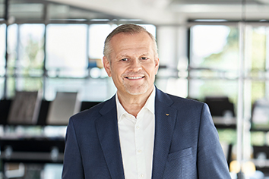
Andreas Engelhardt, Managing Partner of Schüco International KG.

Photographer: Frank Peterschröder
Usage rights: Schüco International KG
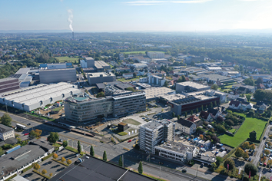
The Schüco Campus in Bielefeld with the Schüco One newbuild, the new Schüco Welcome Forum and the renovated Schüco Corporate Services building.

Photographer: rolandborgmann.com
Usage rights: Schüco International KG
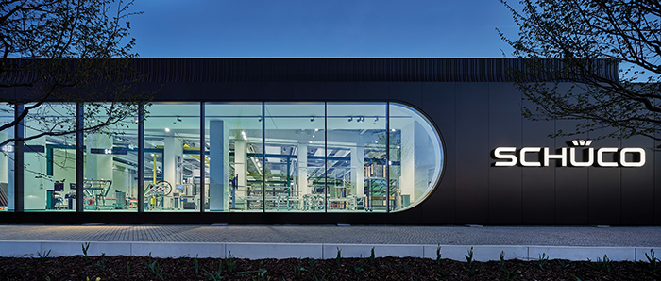
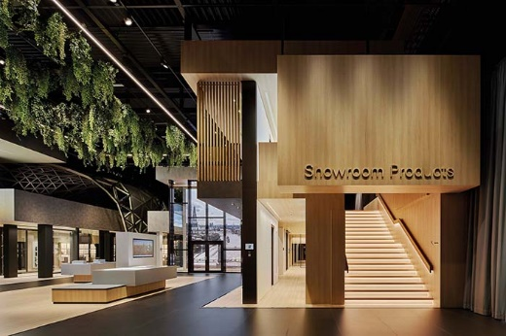
Across an area of 4650 square metres, the new Schüco Welcome Forum showcases the current product range, digital solutions and machinery for efficient metal fabrication.

Picture credits: Schüco International KG
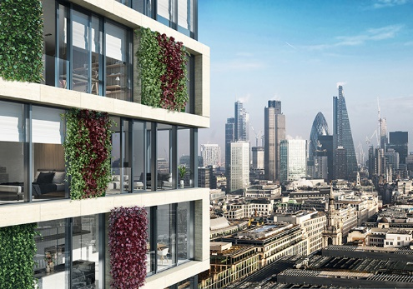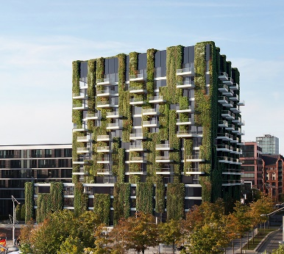
Green façades like Schüco AF UDC 80 offer many benefits. They improve the climate in cities by absorbing CO₂ and clean the air of particulates and harmful substances. At the same time, green façades produce oxygen, compensate for the loss of green spaces and make the cityscape more attractive and vibrant, so that people enjoy living and spending time there.

