Press release  July 2022 |  | Further information about publication:  Schüco International KG  Ulrike Krüger  Karolinenstr. 1–15  33609 Bielefeld, Germany  Tel.: +49 (0)521 783-803  Fax: +49 (0)521 783-950803  E-mail: PR@schueco.com  www.schueco.com/press  www.schueco.com/press

New Plant 4 building for Roma in Burgau

A clever combination of sun shading and façade creates visual harmony

Bielefeld. The German town of Meißen is known for porcelain, Brakel for fittings and Burgau for sun shading. The Plant 4 newbuild, located at sun shading manufacturer Roma's premises in Bavaria's Swabia region, demonstrates just what high quality can look like in terms of appearance and durability.The textile sun shading system is seamlessly integrated in the Schüco unitised façade, creating a harmonious whole. The sun shading blind cannot be seen when open but, when lowered, supports the high-quality design of the façade with its colour scheme and transparency.

The company premises of Roma KG are embedded in a modern landscape architecture with a pond area, flowerbeds and grass lawns criss-crossed with walkways. This is where Plant 4, the new 10,000 m² production hall, has been constructed for the manufacture of attachment systems for roller shutters, external blinds and textile screens. The upper floor of the industrial newbuild also contains around 50 workspaces, a "floating office" with a further six workspaces for the plant management team, a kitchenette and a conference room.

In the car park in front of the plant there are rusty brown-coloured shelters made of Corten steel, as well as a bistro for visitors and employees. They create a striking contrast to the anthracite grey of the plant façade. Generous, double-storey glazing on the south and west side allows maximum daylight into the offices behind. When it is very sunny, the textile screens on the outer façade can be lowered to shade the workspaces and combat overheating. "The textile sun shading system reduces bothersome glare on the monitors." At the same time, it allows views to the outside to be retained even when the sun shading is lowered," says Dr Mathias Klaiber, Head of Textile Screen Development at ROMA. "It was important to us to have a harmonious, high-quality design for the outdoor area. That's why we kept the sun shading and the façade in the same colour. So when the sun shading is closed, the building has a uniform look. The textile blind also looks calming and even, so fits in perfectly with the appearance of the façade.

The textile sun shading system which is fully integrated in the façade is the Schüco Aluminium Blind Zip Design Screen (AB ZDS). The textile blind runs on narrow guide tracks and is integrated in the load-bearing system of the façade. Both the integrated zip technology and the textile fabric of the sun shading were produced by Roma. The fabric used on the Plant 4 newbuild is in the Serge 5% design in coal / coal with 5% transparency. The Schüco façade units are in the matching RAL colour 7021 Black Grey matt. On cloudy days or as required, the sun shading can be fully retracted and is almost completely concealed.

Another benefit of the external sun shading system is its high level of weather resistance. It additionally offers stability in wind speeds of up to 25 metres per second – this corresponds to 9-10 on the Beaufort scale. Furthermore, it is easy to maintain and resistant to tearing.

Project details
Location: Ostpreußenstraße 9, Burgau
Client and user: Roma KG, Burgau
Architects: ALEA Architektur GmbH, Günzburg
Window fabricator / Schüco fabricator: Siegfried Wölz Stahl- und Metallbau GmbH & Co. KG, Gundelfingen

Schüco materials/products installed:
Sun shading system: AB ZDS (Aluminium Blind Zip Design Screen) in Schüco AF UDC 80 façade system (Aluminium Façade Unitized Dynamic Construction, face width min. 80 mm)
Window system: AWS 75 BS.HI (Aluminium Window System, Block system / Block window, High Insulated)
Door system: ADS 75 HD.HI (Aluminium Door System, 77 mm basic depth, Heavy Duty, High Insulated)
Fire protection system: ADS 80 FR 30 (Aluminium Door System, 80 mm basic depth, Fire Resistant), fire resistance class EI 30 (T/F 30) and EW 30 (G 30))

Completion date: May 2021

Schüco – System solutions for windows, doors and façades
Based in Bielefeld, the Schüco Group develops and sells system solutions for windows, doors and façades. With 6330 employees worldwide, the company strives to be the industry leader in terms of technology and service both now and in the future. In addition to innovative products for residential and commercial buildings, the building envelope specialist offers consultation and digital solutions for all phases of a building project – from the initial idea through to design, fabrication and installation. Schüco works with 10,000 fabricators and 30,000 architectural practices, as well as construction professionals, who commission buildings around the world. Founded in 1951, the company is now active in more than 80 countries and achieved a turnover of 1.995 billion euros in 2021. For more information, visit www.schueco.com

High resolution images are available to download in the Schüco Newsroom at www.schueco.com/press.

Photographer: Jochen Helle
Usage rights: Schüco International KG
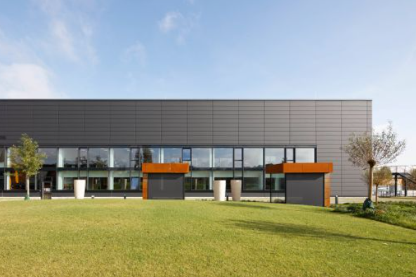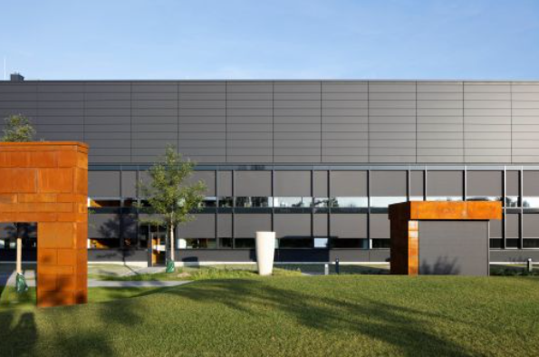
Corten steel shelters in the car park in front of the west façade.

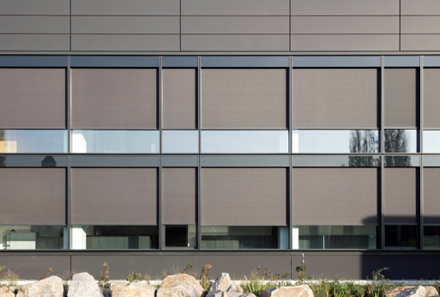
The textile sun shading boasts a smooth fabric appearance. It is partly open.

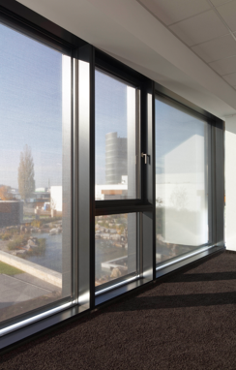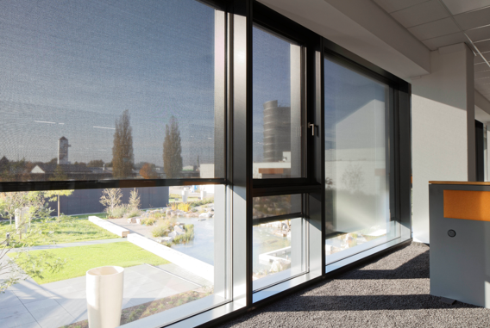
The glass fibre fabric creates a good balance between translucency and glare protection.

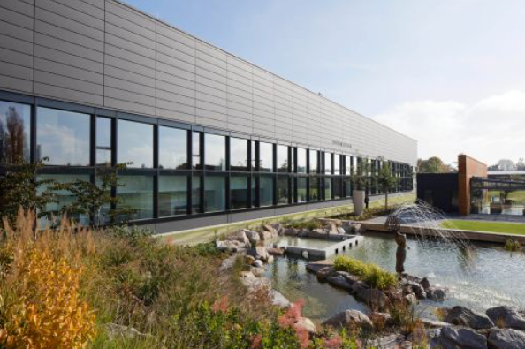
Plant 4 is embedded in a modern landscape architecture with a bistro and pond area.

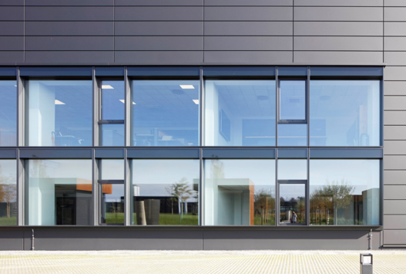
On cloudy days or as required, the sun shading can be fully retracted and is almost completely concealed.

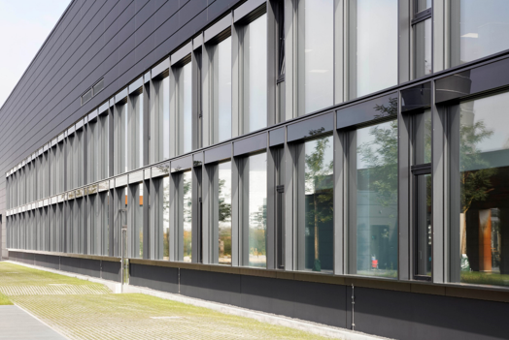
The Schüco AF UDC 80 façade system stretches over the entire long section of the façade.

