Press release  June 2022 |  | Further information about publication:  Schüco International KG  Ulrike Krüger  Karolinenstr. 1–15  33609 Bielefeld, Germany  Tel.: +49 (0)521 783-803  Fax: +49 (0)521 783-950803  E-mail: PR@schueco.com  www.schueco.de/presse  www.schueco.com/press

For windows, doors, façades and special profiles:

The Schüco AF 510 CNC machine

Bielefeld. The new Schüco AF 510 CNC machine builds on the Schüco AF 500, offering new technology and increased performance for efficient and precise six-sided processing. The highly dynamic five-axis machine features improved spindle performance of 22 kW, integrated vibration monitoring and clamps with decentralised operation. This processing centre therefore provides an efficient and flexible foundation for practically any metal fabrication task.

Milling, cutting, and notching are all possible with just one machine: the new Schüco AF 510 processing centre. The core of the CNC machine is the high-performance, 22 kW spindle in conjunction with a new spindle cooling system. Together with the integrated vibration monitoring, the processing centre enables preventative maintenance to be carried out and paves the way towards Industry 4.0. At the request of the metal fabrication companies, which contributed important practical experience to the development of the machine, the new CNC machine also features a hinge conveyor belt and oil mist extraction system. Clamps with decentralised operation further support efficient fabrication. They allow for simultaneous processing with a feed rate of up to 25 m/min. Automatic pressure monitoring in the clamping devices accelerates the start of the process. Alternating operation mode also allows both sides of the machine to be used in parallel. Automatic positioning of the clamps and easy insertion of the profiles simplify operation for fast and efficient fabrication.

Flexibility and efficiency combined
The Schüco AF 510 CNC machine is particularly flexible when it comes to machining aluminium window, door, façade and special profiles. Thanks to the powerful drive and motor technology, the machine can efficiently process even larger profile cross sections. The absolute position-measuring systems in all six axes mean the axes no longer need to be referenced. In addition, the perfectly balanced machine configuration enables notching from below and processing close to the clamping device. The Schüco AF 510 processing centre is also visually impressive, with a modern design including an LED status display. Robust, durable safety bumpers with leather covers add a finishing touch to the machine. Like the Schüco AF 500 CNC machine, the AF 510 can be combined with the RX LOAD 500 fabrication robot, which was developed together with KUKA for autonomous loading and unloading. The AF 510 processing centre and the robot cell can be seen in action in the glazed Fabrication Showroom in the new Schüco Welcome Forum.

More information is available at www.schueco.de/af510.

Schüco – System solutions for windows, doors and façades
Based in Bielefeld, the Schüco Group develops and sells system solutions for windows, doors and façades. With 6330 employees worldwide, the company strives to be the industry leader in terms of technology and service both now and in the future. In addition to innovative products for residential and commercial buildings, the building envelope specialist offers consultation and digital solutions for all phases of a building project – from the initial idea through to design, fabrication and installation. Schüco works with 10,000 fabricators and 30,000 architectural practices, as well as construction professionals, who commission buildings around the world. Founded in 1951, the company is now active in more than 80 countries and achieved a turnover of 1.995 billion euros in 2021. For more information, visit www.schueco.com

High resolution images are available to download in the Schüco Newsroom at www.schueco.com/press.

Picture credits: Schüco International KG
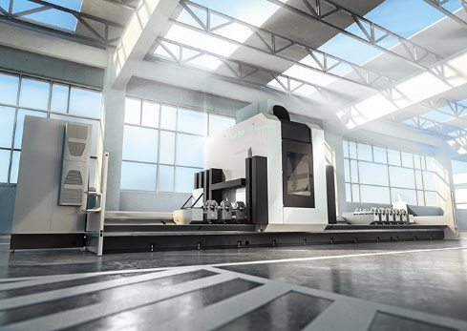
Schüco AF 510 is a further development of the AF 500 and one of the highest performance five-axis machines on the market.

Picture credits: Schüco International KG
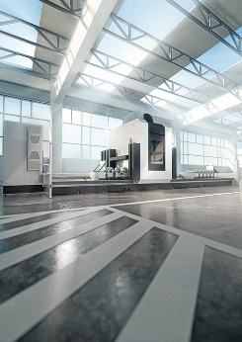
The Schüco AF 510 CNC machine offers a high degree of flexibility and openness specifically for the fabrication of aluminium window, door, façade and special profiles.

