Press release  June 2022 |  | Further information about publication:  Schüco International KG  Ulrike Krüger  Karolinenstr. 1–15  33609 Bielefeld, Germany  Tel.: +49 (0)521 783-803  Fax: +49 (0)521 783-950803  E-mail: PR@schueco.com  www.schueco.de/presse  www.schueco.com/press

Inspiration, information and interaction:

A warm Schüco welcome across 4650 square meters

Bielefeld. The new Schüco Welcome Forum offers guests a comprehensive insight into the world of Schüco. Visitors are able to learn about the current product portfolio, a wide range of services and digital solutions, as well as machinery for efficient metal fabrication. A café, the Newsroom and meeting rooms round off the visitor experience and provide space for face-to-face interaction.

“The Schüco Welcome Forum is the heart of Schüco, and this heart beats for our guests,” explains Andreas Engelhardt, Managing Partner of Schüco. The visitor centre is the first port of call on the Schüco Campus and a central hub for fabricators, clients, architects, investors and Schüco employees. A central foyer connects the five different areas – the Product Showroom, the Fabrication Showroom, the café, the Newsroom, and the meeting and workshop rooms – and gives visitors a panoramic view of the Schüco systems on display and installed on the campus.

Product Showroom
The Product Showroom allows visitors to get up close and hands on with all of the products, digital solutions and services for residential and commercial construction across approximately 800 square meters. The 8 metre-tall hall houses a total of 28 large exhibits and a further 45 display units covering the areas of Health, Security and Smart. What Schüco understands by ‘Healthy Building’ can be seen in the displays for the sound reduction window, the antimicrobial surface protection, green façades, entrance, patio and sliding doors without thresholds, sun shading, screening and much more. High security, fire-resistant and burglar-resistant systems can be found in the Security area. And how intelligent solutions and products can make life easier and safer, and how easy they are to use, is demonstrated by the smart product range from Schüco. From intelligent building control and convenient window and sliding door automation right through to healthy ventilation systems, Schüco presents its intelligent, networked products and systems for smart living here. Not to mention the comprehensive digital solutions on display in the Product Showroom that have made the Bielefeld-based company a pioneer in the industry since the 1970s. These exhibits are complemented by the Service area. Whether it's the after sales service, partner consulting or the training and specification service, the showroom demonstrates just what excellent service means at Schüco.

Fabrication Showroom
30 machines, big and small, can be seen in action across 2000 square meters in the glazed Fabrication Showroom. The metal fabrication machines are installed in the following categories: prefabrication, sawing, CNC processing, milling – drilling – punching, assembly and shop floor equipment. The Schüco team set up the production line to replicate the size of a typical metal fabrication operation. This means that guests will be able to experience in action the right machinery for them and their processes and see what a workshop tailored to their needs could look like. The Fabrication Showroom therefore showcases the AS 100 continuous feed machining centre, which alone requires an area of around 160 square meters. The new RX LOAD 500 fabrication robot consisting of a 5-axis CNC machine and robot technology from KUKA – the first Schüco solution in the field of robotics – can also be experienced up close. On touchscreens, visitors can display the locations of the machines in the fabrication hall in 3D and call up technical details, benefits for fabricators, videos and images of the machines.

Café, Newsroom and conference rooms
After the tour through the world of Schüco, the café and adjacent outdoor area provides a place to recharge your batteries and discuss the events of the day. Right next door is the Schüco Newsroom, where the Schüco brand is presented and questions about sustainability, reference projects, the company history and the campus are answered. Meeting and conference rooms provide the perfect space to discuss any queries with Schüco employees.

Schüco showrooms throughout Germany
In addition to the Welcome Forum in Bielefeld, six other showrooms across Germany also showcase current Schüco innovations. What's more, the showrooms in Berlin and Düsseldorf have just re-opened. With its exposed location at the heart of City West, the Schüco showroom in Berlin is a very attractive venue. Following the renovation, all of the exhibits for residential and commercial construction can now be experienced in real-life installation scenarios. The new digital display window right next to the showroom can be used to showcase reference projects, hot topics and upcoming events. The showroom at Düsseldorf Medienhafen is a combination of a showroom, seminar area and event space across almost 400 square meters. Thanks to a large window façade with a view out over the Medienhafen, this Schüco showroom is at the centre of what could be described as an open-air exhibition of Schüco reference projects. In addition to Bielefeld, Berlin and Düsseldorf, the building envelope specialist has showrooms in Hamburg, Frankfurt, Wertingen and Weißenfels. Schüco is also represented internationally, with 15 further showroom locations across the globe, including New York, Beijing and Dubai.

More information about the Schüco Welcome Forum and how to register for a visit is available at the following link: schueco.com/showroom/welcome-forum-bielefeld

Project details

Architectural practice: one fine day, Düsseldorf
Building concept and implementation: Goldbeck GmbH, Bielefeld
Concept and design of Product Showroom and Newsroom: D'art Design Gruppe GmbH, Neuss
Development of Product Showroom and Newsroom: kohlhaas GmbH & Co. KG, Germering
Communication concept and content: D'art Design Gruppe GmbH, Neuss

Schüco – System solutions for windows, doors and façades
Based in Bielefeld, the Schüco Group develops and sells system solutions for windows, doors and façades. With 6330 employees worldwide, the company strives to be the industry leader in terms of technology and service both now and in the future. In addition to innovative products for residential and commercial buildings, the building envelope specialist offers consultation and digital solutions for all phases of a building project – from the initial idea through to design, fabrication and installation. Schüco works with 10,000 fabricators and 30,000 architectural practices, as well as construction professionals, who commission buildings around the world. Founded in 1951, the company is now active in more than 80 countries and achieved a turnover of 1.995 billion euros in 2021. For more information, visit www.schueco.com

High resolution images are available to download in the Schüco Newsroom at www.schueco.com/press.

Photographer: rolandborgmann.com
Usage rights: Schüco International KG

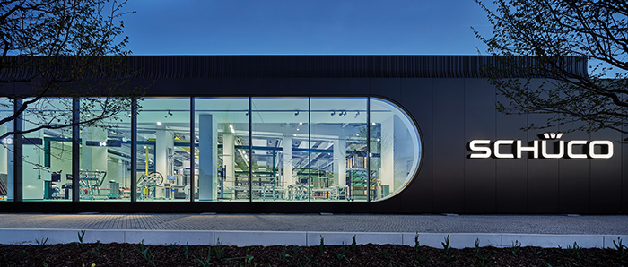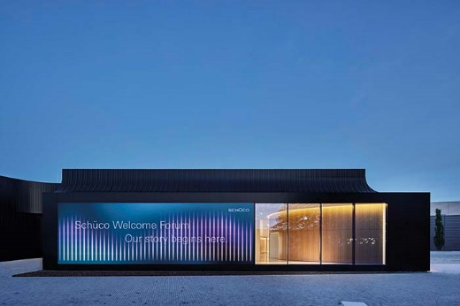
The new Schüco Welcome Forum presents the entire Schüco world across 4650 square meters.
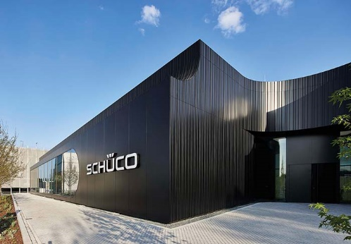
From the idea and planning right through to fabrication, installation, operation and maintenance, the Welcome Forum at the heart of the Schüco Campus showcases Schüco solutions for the entire value chain of a building project.

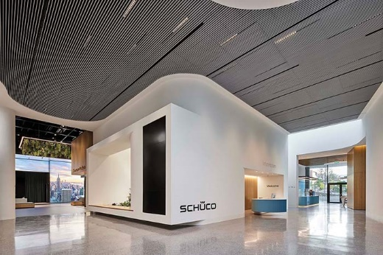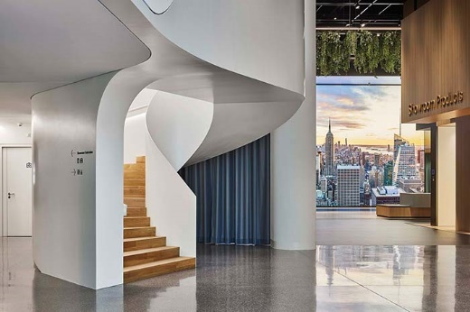
A central foyer connects all the different areas of the Schüco Welcome Forum and offers visitors a 360° view of the entire Schüco world.

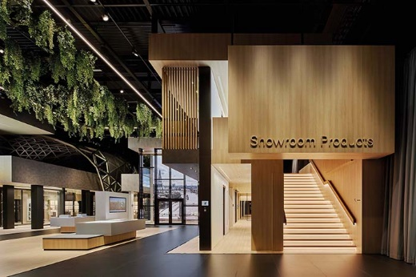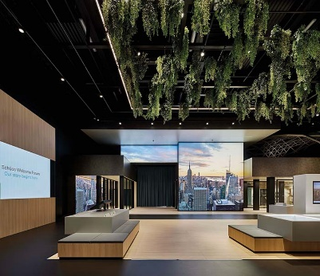
The Product Showroom also features large exhibits such as the Grid2Shell freeform façade and a high-security façade.

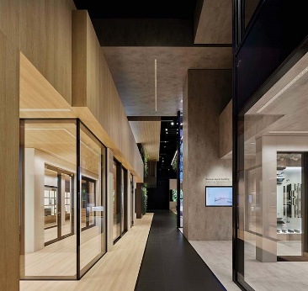
Large sliding systems for healthy and secure living can not only be viewed in the Product Showroom but also touched and tried out.

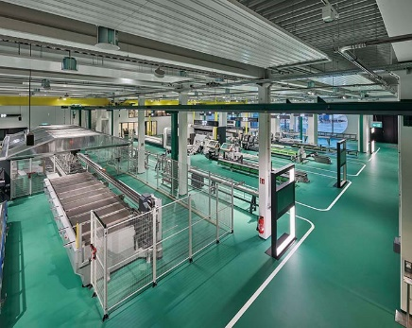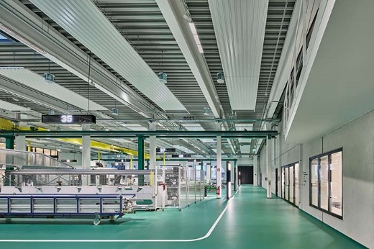
Measuring 2000 square meters, the Fabrication Showroom accounts for almost half of the Welcome Forum and showcases a complete production line. Thanks to large ribbon windows, the machinery area can also be viewed from outside and functions as a glazed factory.
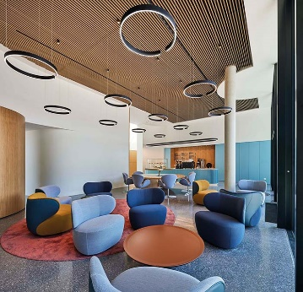
The café and adjacent outdoor area provide a place to recharge your batteries and discuss the events of the day.

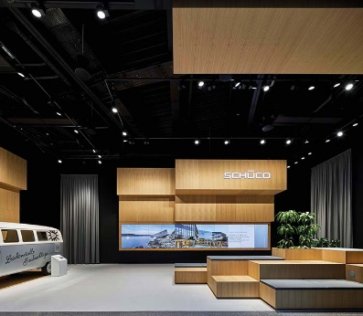
In the Schüco Newsroom there is a large screen – the Newspool – which displays information about the company and offers inspiration for visitors.
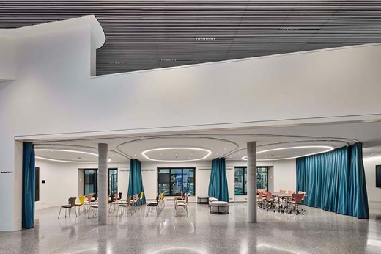
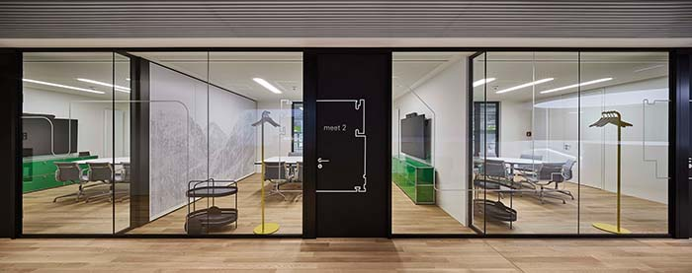
Several meeting and conference rooms provide the perfect space for guests to discuss any queries with Schüco employees.

