Press release  May 2022 |  | Further information about publication:  Schüco International KG  Ulrike Krüger  Karolinenstr. 1-15  33609 Bielefeld, Germany  Tel.: +49 (0)521 783-803  Fax: +49 (0)521 783-950803  E-mail: PR@schueco.com  www.schueco.com/press  www.schueco.com/press

Fraunhofer IWKS in Hanau

Sustainability across the board

Bielefeld. In Hanau, the Fraunhofer IWKS Research Institution explores the fields of resource strategies, recycling and material cycles. This is also reflected in the concept implemented for the office and laboratory building that was constructed there in 2020 by Stuttgart-based architectural practice hammerskrause architekten. The façade solutions from Schüco make an important contribution towards the sustainability of the newbuild.

On the site of a former army barracks in Hanau's Wolfgang district (on the plot of the Wolfgang Kaserne army barracks) the Fraunhofer Science Park will be constructed over the next few years. The aim of the urban initiators is to bring together research, development and production geographically so that synergies can be fully utilised. The Fraunhofer Society laid the foundations for the new Hanau industrial park in 2020 with the construction of the Fraunhofer Research Institution for Materials Recycling and Resource Strategies (IWKS). The IWKS researches new processes and technologies for the efficient handling of raw and processed materials that are intended for the industry and that have been produced by the industry. Their goal is “a closed material cycle in which there is no or hardly any waste. Waste is avoided by recovering and recycling valuable raw materials or replacing them with sustainable alternatives,” according to their website. Experienced in the construction of research facilities, Stuttgart-based architectural practice hammeskrause designed and implemented the newbuild under the leadership of architect Markus Hammes.

A flexible, modular construction
The Fraunhofer IWKS building has a floor area of 2600 m² and is set up for the current 80-person project team. It is situated on a spacious plot interspersed with greenery and wooded areas where individual structures are integrated, all with different building types, numbers of storeys and sizes. It therefore made sense to design the newbuild as a solitary construction with a flexible, modular base structure to allow for any future extensions. The different functions of the facility – office, laboratory, workshop and pilot plant – are allocated three different building structures. The shape and size of the units reflect the respective functional requirements. The three volumes are linked via a covered and extendable axis which is known as "Researcher's Street”. This connects the different areas efficiently, making it easy to find your way around the building.
The atrium as the communicative heart of the building
The main building of the research facility has a square floor plan and houses offices as well as communal spaces such as meeting and seminar rooms, kitchenettes and lounge areas. They are all grouped around a three-storey atrium with a glass roof. It is the heart of the building and its stand-out feature and, in addition to Researcher's Street, is the main location where the researchers can meet and chat informally. This not only makes the building a place where people enjoy spending time, but also encourages creativity and innovation among those who work there.

The laboratories line the connecting axis and form a flat structure. The workshop on the other side of Researcher's Street is visibly set apart due to its striking sawtooth roof. It stretches across two-and-a-half storeys because of the large measuring equipment and test rigs that it houses.

Recyclable materials
All of the façades of the building are designed as suspended rear-ventilated constructions. While the laboratory building and the workshop are clad in galvanised sheet steel panels arranged vertically, the uniform envelope of the main structure is made from grey fibre reinforced cement panels arranged horizontally. Ribbon windows from the passive house-certified Schüco AWS 120 CC.SI system allow daylight to flood the offices, while windows from the highly thermally insulated Schüco AWS 75.SI+ system have been fitted in the laboratories which line the connecting axis. The likewise highly thermally insulated mullion/transom façade on Researcher's Street made from the Schüco FWS 50.HI system creates a visual link to the outside space.

As the Fraunhofer IWKS focuses its research on recycling and closed material loops, recyclable materials logically played a key role in the building itself too. This was implemented in the façade by using products which can be separated by type, such as cladding made from fibre reinforced cement and sheet steel, as well as the C2C Silver certified Schüco AWS 75.SI+ and AWS 120 CC.SI window systems. This certification means that the unit can be dismantled and fed back into the material cycle after use. Furthermore, environmentally friendly substances are used in the product as well as renewable energy during manufacture. As some of the measuring equipment used for research at IWKS is very sensitive to vibrations, the building had to be constructed out of reinforced concrete. And even the concrete building shell consists of 20 percent recycled material.

Management of natural light
The AWS 120 CC.SI window system installed in the office façade has integrated sun shading thanks to the CCB composite blind. Project management partner Markus Hammes explains why he chose this product: “The building is situated on an open plot. So it is particularly important for the sun shading to be protected against wind and weathering.” He was also impressed by the excellent structural values of the system and the ability to control the sun shading to suit individual requirements. According to Hammes, another plus point is that the units can be easily cleaned from the outside. “For flush-fitted façades, I can highly recommend the AWS 120 CC.SI,” sums up the architect.
Access control and window monitoring
The IWKS Hanau building is not accessible to the public. As standard, it has networked building services with access control and window monitoring. On the inside, the building is divided into areas that are freely accessible by researchers and visitors, such as the atrium and the adjoining communal areas, as well as zones and spaces that can only be entered via a separate access control system. This approach was made easier by the clearly structured floor plan. “It is sometimes the case that the IWKS is researching the same topic for different clients. The different research groups therefore have to be able to work and welcome their clients in separate areas,” explains Hammes.

BNB silver certified
The IWKS has been certified according to the German Assessment System for Sustainable Building (BNB). In addition to ecological and socio-cultural aspects, this also took into account building planning and implementation issues.
For the energy concept of the Fraunhofer IWKS, the planners took a low-tech approach. They used natural processes, such as the air circulation in the atrium, to lower the energy consumption in the building. At the same time, they fully utilised the solar gains and natural light. The compact shape and an envelope based on highly thermally insulated Schüco window systems that are suitable for passive houses prevent heat loss in winter. The simplicity and balance of the materials not only reflects the requirements of the building project but also exemplifies sustainability in the truest sense of the word.

Project details

Project title: Fraunhofer Research Institution for Materials Recycling and Resource Strategies IWKS, Hanau
Architectural practice: hammeskrause architekten
Fabricator: Grebenauer Metallbau Schreiner GmbH, Grebenau
Completion date: 2018
Schüco products installed:
- Mullion/transom façade: Schüco FWS 50.HI (Façade Window System, 50 mm face width, Highly Insulated)
- Composite window: Schüco AWS 120 CC.SI (Aluminium Window System, 120 mm face width, Composite Construction Super Insulated)
- Sun shading: Schüco CCB (Concealed Composite Blind) integrated in the AWS 120 CC.SI composite window
- Window system: Schüco AWS 75.SI+ (Aluminium Window System, 75 mm basic depth, Super Insulated)
- Smart building: Sun shading control system
Schüco – System solutions for windows, doors and façades
Based in Bielefeld, the Schüco Group develops and sells system solutions for windows, doors and façades. With 6330 employees worldwide, the company strives to be the industry leader in terms of technology and service both now and in the future. In addition to innovative products for residential and commercial buildings, the building envelope specialist offers consultation and digital solutions for all phases of a building project – from the initial idea through to design, fabrication and installation. Schüco works with 10,000 fabricators and 30,000 architectural practices, as well as construction professionals who commission buildings around the world. Founded in 1951, the company is now active in more than 80 countries and achieved a turnover of 1.995 billion euros in 2021. For more information, visit www.schueco.com

High-resolution pictures are available to download in the Schüco Newsroom at www.schueco.com/press

Photographer: Christian Eblenkamp
Usage rights: Schüco International KG

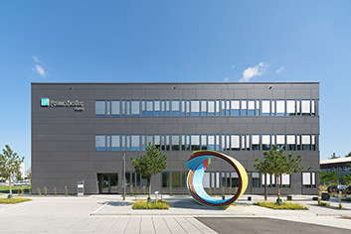
The new office, laboratory and workshop building of the IWKS in Hanau provides around 2600 m² of useable space for approx. 80 employees.

Photographer: Christian Eblenkamp
Usage rights: Schüco International KG
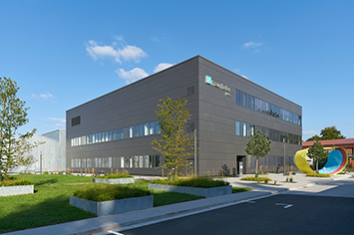
The compact construction has a suspended, rear-ventilated façade made from reinforced fibre cement panels. Ribbon windows from the AWS 120 CC.SI system ensure there is plenty of natural light in the offices.

Photographer: Christian Eblenkamp
Usage rights: Schüco International KG
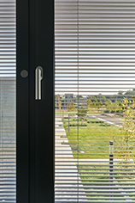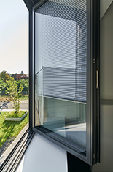
The 120 CC.SI window system installed in the office façade has integrated sun shading thanks to the CCB composite blind.

Photographer: Christian Eblenkamp
Usage rights: Schüco International KG
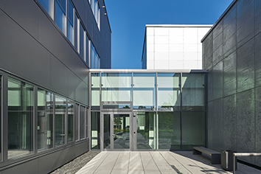
The individual functional areas are linked via the so-called “Researcher's Street”. The mullion/transom façade made from the Schüco FWS 50.HI system creates a visual link to the outside space.

Photographer: Christian Eblenkamp
Usage rights: Schüco International KG
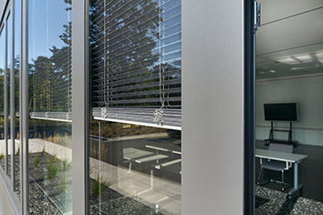
The CCB composite blind sun shading can be controlled individually if required.

Photographer: Christian Eblenkamp
Usage rights: Schüco International KG
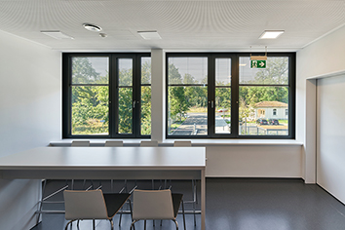
For the office spaces, the architects specified ribbon windows from the Schüco AWS 120 CC.SI system with integrated sun shading.

Photographer: Christian Eblenkamp
Usage rights: Schüco International KG
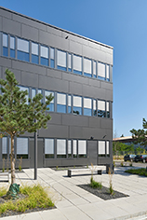
The building is situated on an open plot. In the AWS 120 CC.SI composite windows, an impact panel at the front protects the integrated sun shading from the wind and weather.

Photographer: Christian Eblenkamp
Usage rights: Schüco International KG
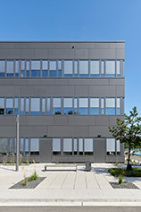
Long ribbon windows and façade cladding made from grey reinforced fibre cement panels positioned horizontally structure the main Fraunhofer IWKS building.

Photographer: Christian Eblenkamp
Usage rights: Schüco International KG
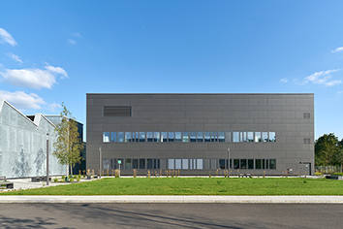
The square main building of the research institute houses offices and communal areas, among other things. The workshop is visibly set apart due to its sheet steel façade and striking sawtooth roof.
Photographer: Christian Eblenkamp
Usage rights: Schüco International KG
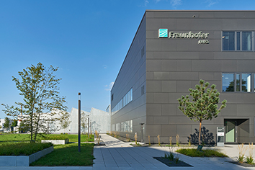
The IWKS Hanau is a highly secure building that is not accessible to the public. As standard, it has networked building services with access control and window monitoring.

