Press release  February 2020 |  | Further information about publication:  Schüco International KG  Ulrike Krüger  Karolinenstr. 1–15  33609 Bielefeld  Tel.: +49 (0)521 783-803  Fax: +49 (0)521 783-950803  E-mail: PR@schueco.com  www.schueco.de/presse  www.schueco.com/press

Hall 7, Stand 7-503

Schüco at FENSTERBAU FRONTALE 2020

Bielefeld/Weißenfels. Schüco Polymer Technologies KG is presenting pioneering windows, entrance doors and sliding doors for the residential market at FENSTERBAU FRONTALE 2020. In Hall 7, Stand 7-503, under the tagline "Home is everything", the company provides a vision of the desires of clients both today and tomorrow, displaying smart, barrier-free PVC-U and aluminium products. Taking centre stage is a service area bursting with eye-catching colour that illustrates the wide selection of services and digital solutions with which Schüco comprehensively supports its partners in all stages of the business process.

The Schüco exhibition stand, covering more than 580 m², is divided into the SERVICE area and the three product areas PANORAMA, VIEW and ARRIVAL, all positioned around a central plaza.

The SERVICE area shows the extensive range of services offered by Schüco Polymer Technologies KG. Here the spotlight is on digital solutions: Schüco PolyCal, mutually developed by Orgadata and Schüco, is a new window design software with which Schüco PVC-U windows, doors and sliding doors can be calculated and fabricated easily and efficiently. Also new is the Schüco PolyWeb online platform, which can be used to quickly and effectively plan and calculate special PVC-U building units. Other highlights are PlanToBuild, the cross-trade construction project management software, and the building product comparison portal Plan.One. The SERVICE area also offers exhibition attendees the opportunity to learn about new machinery such as the DF-100 gasket milling machine and GLF-100 glazing bead milling machine.

In the PANORAMA area, the focus is on extremely narrow profile face widths and large glazed areas combined with comfort and high-quality design. On display here are the new Schüco LivIngSlide options, for example in combination with zero level thresholds and concealed electronic drives. Schüco is surprising visitors to the exhibition stand with a LivIngSlide vent profile with a narrow face width of just 72 mm – an amazing measurement for PVC-U lift-and-slide systems. Prefabricated ‘threshold kits’ that allow partners to quickly and efficiently fabricate these Panorama Design lift-and-slide doors are on show and can be ordered from Schüco following the exhibition. In addition, the company unveiled the new Schüco SoftSlide sliding system as well as the new lift-and-slide generation Schüco EasySlide. This completes the PVC-U sector's sliding system portfolio and provides suitable solutions for the requirements of every client.

In the VIEW area, visitors can to take a look at a new design window system which combines aluminium and PVC-U, distinguished by narrow face widths and a minimalist, angular design. The aluminium on the outside is coloured using powder coating, while a selection of different foils are available for the PVC-U profile facing the building interior. In terms of smart solutions for windows, an energy self-sufficient remote closing monitoring system and a digital window with a QR code are also on display. The code takes the user to an app with various functions which allows a maintenance order to be placed, for example. Comfort and health are addressed by zero-level thresholds for turn/tilt and double-vent LivIng series units and the window-integrated Schüco VentoTherm Twist ventilation solution, as well as the Schüco Integralmaster internal sun shading system.

The ARRIVAL area features entrance doors in combination with Schüco DCS SmartTouch and Schüco BlueCon. The new Schüco DCS (Door Control System) SmartTouch combines audiovisual door communication with easy-to-use, secure access control. The system brings together a camera, doorbell and access control in a single module with a stylish design. All of the components are commissioned and controlled via the new Schüco app. The Schüco BlueCon access control module uses Bluetooth technology to enable you to use your smartphone to operate your entrance door without a key. The module, which is concealed in the door rebate, checks access authorisation when a person approaches the door. The Schüco BlueCon app can be used to open the door automatically or manually, depending on the settings. Access authorisations can be set individually, flexibly and for specific people.

Schüco – System solutions for windows, doors and façades
Based in Bielefeld, the Schüco Group develops and sells system solutions for windows, doors and façades. With 5400 employees worldwide, the company strives to be the industry leader in terms of technology and service today and in the future. In addition to innovative products for residential and commercial buildings, the building envelope specialist offers consultation and digital solutions for all phases of a building project – from the initial idea through to design, fabrication and installation. 12,000 fabricators, developers, architects and investors around the world work together with Schüco. The company is active in more than 80 countries and achieved a turnover of 1.670 billion euros in 2018. For more information, visit www.schueco.com

High-resolution pictures are available to download in the Schüco Newsroom at www.schueco.com/press.

Picture credits: Schüco Polymer Technologies KG
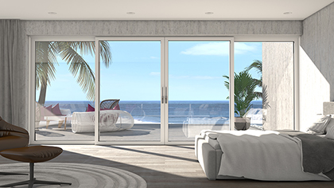
The Schüco LivIngSlide lift-and-slide system with the new vent profile in a narrow face width of just 72 mm.

Picture credits: Schüco Polymer Technologies KG
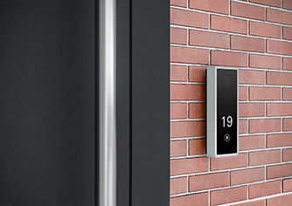
The Schüco DCS (Door Control System) SmartTouch – shown here in the surface-mounted design – combines audiovisual door communication with easy-to-use, secure access control. The system brings together a camera, doorbell and access control in a single module with a stylish design.

Picture credits: Schüco Polymer Technologies KG
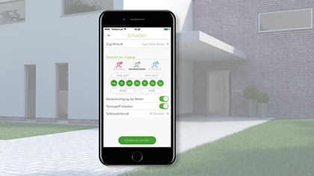
The Schüco BlueCon access control module uses Bluetooth technology to enable you to use your smartphone to operate your entrance door without a key.

