Press release  December 2021 |  | Further information about publication:  Schüco International KG  Ulrike Krüger  Karolinenstr. 1–15  33609 Bielefeld, Germany  Tel.: +49 (0)521 783-803  Fax: +49 (0)521 783-950803  E-mail: PR@schueco.com  www.schueco.de/presse  www.schueco.com/press

Energy self-sufficient monitoring of closing with added value

Schüco SensTrack wireless

Bielefeld. Schüco SensTrack wireless is an intelligent sensor that monitors the locking status of Schüco window systems. The patented smart system for monitoring of closing notifies the user if the window is securely locked, without requiring an external energy supply to do so. The movement of the fitting supplies the battery-free wireless sensor with kinetic energy, making it energy self-sufficient, sustainable and maintenance-free.

Located in a concealed position, Schüco SensTrack wireless permanently monitors the locking status of the window. The energy required for wireless communication with an EnOcean-compatible smart home control unit is generated by the energy self-sufficient monitoring of closing system from the movement of the fitting when locking and unlocking the window. The monitoring of closing is integrated in the fittings groove so that it is almost completely concealed, meaning the appearance of the window is unaffected. At the same time, the intelligent wireless sensor can also be networked with other EnOcean-based devices to create added value. When connected to an EnOcean-compatible thermostat, Schüco SensTrack wireless can make your living environment even more comfortable and energy-efficient, by preventing unnecessary heating while the room is being ventilated. When you're on the move, the intelligent sensor also increases security by allowing you to check remotely whether your windows are locked using your smart home app.

Schüco SensTrack wireless can be installed directly in or retrofitted to the Schüco AWS aluminium window systems with AvanTec and AvanTec SimplySmart fittings.

For more information, visit schueco.de/monitoring-of-closing.

Schüco – System solutions for windows, doors and façades
Based in Bielefeld, the Schüco Group develops and sells system solutions for windows, doors and façades. With 5650 employees worldwide, the company strives to be the industry leader in terms of technology and service today and in the future. In addition to innovative products for residential and commercial buildings, the building envelope specialist offers consultation and digital solutions for all phases of a building project – from the initial idea through to design, fabrication and installation. 12,000 fabricators, developers, architects and investors around the world work together with Schüco. The company is active in more than 80 countries and achieved a turnover of 1.750 billion euros in 2019. For more information, visit www.schueco.com

High-resolution pictures are available to download in the Schüco Newsroom at www.schueco.com/press

Picture credits: Schüco International KG
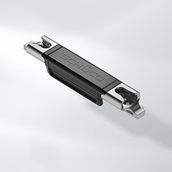
Schüco SensTrack wireless detects and provides information about the locking status of the window for complete security and comfort.

Picture credits: Schüco International KG
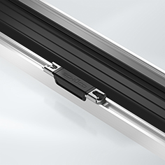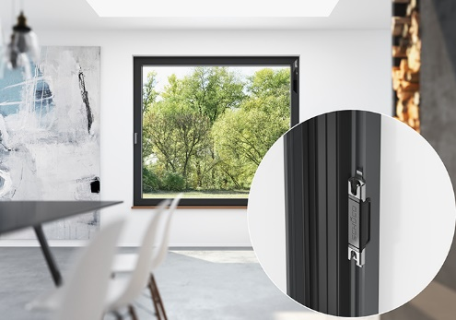
The energy self-sufficient, wireless monitoring of closing system can be easily retrofitted in the fittings groove of existing Schüco windows.
Picture credits: Schüco International KG
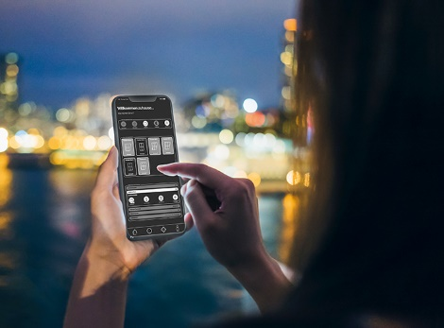
The intelligent sensor also increases security by allowing you to check remotely whether your windows are locked using your smart home app.

Picture credits: Schüco International KG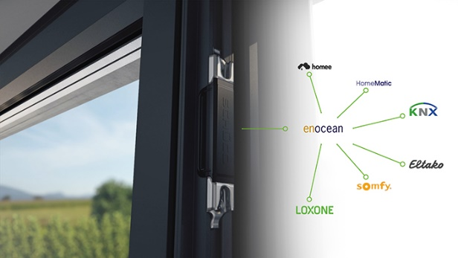
The wireless, battery-free keep can be directly connected to systems that are compatible with EnOcean by means of an additional external gateway.

