Press release  October 2021 |  | Further information about publication:  Schüco International KG  Ulrike Krüger  Karolinenstr. 1–15  33609 Bielefeld, Germany  Tel.: +49 (0)521 783-803  Fax: +49 (0)521 783-950803  E-mail: PR@schueco.com  www.schueco.de/presse  www.schueco.com/press

One façade – maximum design freedom

Schüco Grid2Shell

Bielefeld. The new Schüco Grid2Shell freeform façade is a self-supporting aluminium/glass solution for three-dimensional roof and façade constructions. Together with the Schüco joint venture Nesuchije Systems from Novosibirsk, the building envelope specialist based in Bielefeld has developed a façade solution that offers maximum design freedom and a wide range of possible applications – all without steel substructures or welded joints. Grid2Shell features a self-supporting bolted connection system for simple and rapid fabrication and installation. Schüco offers additional support from the design through to the implementation of the freeform façade for architectural firms and metal fabricators.

Schüco Grid2Shell allows maximum design freedom for three-dimensional façade and skylight constructions. Square, polygonal or triangular module units can be used to create individual shapes on the building envelope, as well as skylight constructions with large spans. The option to have the vertical façade plane transition into the roof gives rise to particularly unique façades. Furthermore, Grid2Shell is also a fully-fledged curtain wall and skylight construction with an all-glass look and outstanding structural, weathertightness and insulation properties.

Stability without any substructure
Unlike most skylight constructions featuring large spans, Grid2Shell does not require any complex and costly substructures. This is because the system is scalable, self-supporting and able to directly accommodate the three-stage sealing system thanks to the profile and node system. The 3D nodes lie at the heart of the system. Each node is made as a one-off piece by the Schüco joint venture Nesuchije Systems. With the help of the self-supporting bolted connection system, the mullion profiles, which are cut at a 90-degree angle, can be screwed to the nodes at the marked point. Additional welded joints are no longer required.

Efficient planning and implementation
Schüco provides comprehensive advice from the design through to the implementation of the freeform façade. This includes the joint venture partner company coming up with improved digital designs, by calculating and optimising the load-bearing structures and node intersection points. The feasibility of the design is also checked using the latest design and structural analysis software. Schüco offers metal fabricators on-site support by providing training and advice at the construction site.

Simple fabrication and installation
The Grid2Shell profiles are first cut at an angle of 90 degrees. The screw holes are then drilled and the pockets machined. Finally, the screw channel is machined. A 5-axis processing centre machines the Grid2Shell nodes out of an entire piece. At present, the fabrication of the nodes is carried out exclusively by our joint venture partner. However, the aim is to enable metal fabricators to carry out fabrication using Schüco machines in the future.
The metal fabricator installs the system on site by means of the snowflake principle. As a result, no large crane devices are required. The numbering of the nodes makes it clear which connecting bar is assigned to which node intersection point and enables straightforward "building by numbers".

www.schueco.com/inow

70 years of Schüco – System solutions for windows, doors and façades
Based in Bielefeld, the Schüco Group develops and sells system solutions for windows, doors and façades. With 5650 employees worldwide, the company strives to be the industry leader in terms of technology and service both now and in the future. In addition to innovative products for residential and commercial buildings, the building envelope specialist offers consultation and digital solutions for all phases of a building project – from the initial idea through to design, fabrication and installation. Schüco works with 10,000 fabricators and 30,000 architectural practices, as well as construction professionals, who commission buildings around the world. Founded in 1951, the company is now active in more than 80 countries and achieved a turnover of 1.695 billion euros in 2020. For more information, visit www.schueco.com

High-resolution pictures are available to download in the Schüco Newsroom at www.schueco.com/press.

Picture credits: Schüco International KG
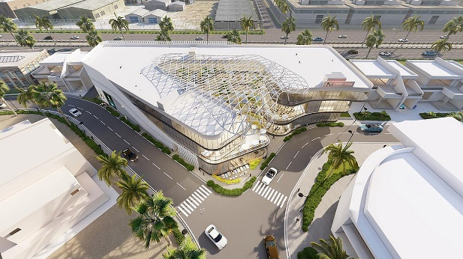
Smart building for the future: Schüco Grid2Shell makes it possible to efficiently plan and easily execute three-dimensional, free-form roof and façade constructions.

Picture credits: Schüco International KG
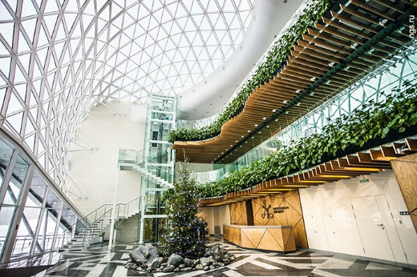
Grid2Shell is scalable, self-supporting and able to directly accommodate the three-stage sealing system thanks to the profile and node system.

Picture credits: Schüco International KG
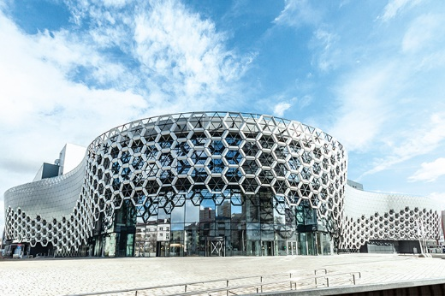
Square, polygonal or triangular module units can be used to create individual shapes on the building envelope, as well as skylight constructions with large spans.

Picture credits: Schüco International KG
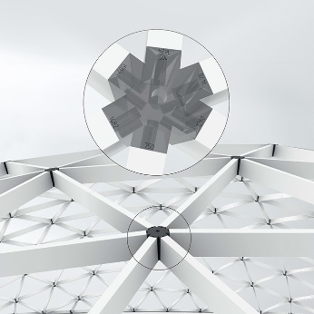
The self-supporting bolted connection system means that steel substructures and welded joints are not required, enabling the construction project to be implemented quickly and efficiently.

