Press release  October 2021 |  | Further information about publication:  Schüco International KG  Ulrike Krüger  Karolinenstr. 1–15  33609 Bielefeld, Germany  Tel.: +49 (0)521 783-803  Fax: +49 (0)521 783-950803  E-mail: PR@schueco.com  www.schueco.com/press  www.schueco.com/press

New fitting for Schüco aluminium windows:

RC 2 burglar resistance in the tilt position

Bielefeld. The new Schüco AvanTec SimplySmart OpenSecure fittings extension for aluminium window systems with tilt-before-turn operation enables ift-tested RC 2 burglar resistance to be achieved in the tilt position. An opening width of up to 175 millimetres is possible when the window vent is tilted. The mechanical fittings system can be integrated into all current Schüco standard and block systems, can be retrofitted and is available immediately.

Not just closed windows can withstand attempted break-ins, tilted ones can too. The entire window construction – consisting of the Schüco aluminium profile, the SimplySmart OpenSecure fitting and impact-resistant glazing – has been tested and certified by ift Rosenheim in accordance with EN 1627 to resistance class RC 2. This has been achieved by adding five security components to the popular SimplySmart mechanical fitting. Securing arms secure the window in the open tilt position, stops regulate the opening width, star inserts secure open screw heads and thereby prevent attempts at tampering, and the combination of an RC case and a keep with a latch secures the tilted window at the bottom. No additional tools are required for fabrication and installation. Insider tip for clients: inform the insurance company that the building is fitted with windows which offer burglar resistance to resistance class RC 2 in the tilt position as well.

The new configuration of the SimplySmart OpenSecure fittings system means that windows can be tilted when locked (tilt-before-turn). A key is only required to open the window in the turn position, e.g. for impact ventilation, cleaning and maintenance.

The new SimplySmart OpenSecure fittings technology can be integrated into all the standard basic depths for the modular Schüco Aluminium Window System (AWS) and can be retrofitted with appropriate pre-configuration – for example, in AWS 75 SI+, AWS 90 SI+ and the flush-fitted AWS 75 BS.SI+ or AWS 90 BS.SI+ systems.

www.schueco.de/inow
www.schueco.de/simplysmart-opensecure

70 years of Schüco – System solutions for windows, doors and façades
Based in Bielefeld, the Schüco Group develops and sells system solutions for windows, doors and façades. With 5650 employees worldwide, the company strives to be the industry leader in terms of technology and service both now and in the future. In addition to innovative products for residential and commercial buildings, the building envelope specialist offers consultation and digital solutions for all phases of a building project – from the initial idea through to design, fabrication and installation. Schüco works with 10,000 fabricators and 30,000 architectural practices, as well as construction professionals, who commission buildings around the world. Founded in 1951, the company is now active in more than 80 countries and achieved a turnover of 1.695 billion euros in 2020. For more information, visit www.schueco.com

High-resolution pictures are available to download in the Schüco Newsroom at
www.schueco.com/press.

Picture credits: Schüco International KG
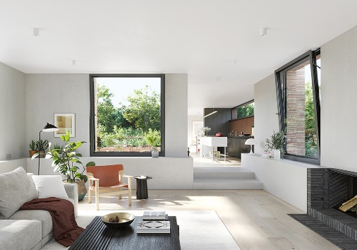
Convenient, secure and functional: Thanks to a new fittings system, Schüco aluminium windows now offer burglar resistance in the tilt position too – up to resistance class RC 2, which is recommended by the police.

Picture credits: Schüco International KG
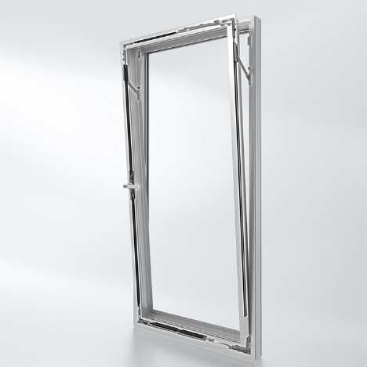
Easy to operate: Tilt the window without having to unlock it. Burglar resistance to RC 2 is possible in the tilt position when locked (tilt-before-turn). A key is only required to open the window in the turn position, e.g. for impact ventilation, cleaning and maintenance.

Picture credits: Schüco International KG
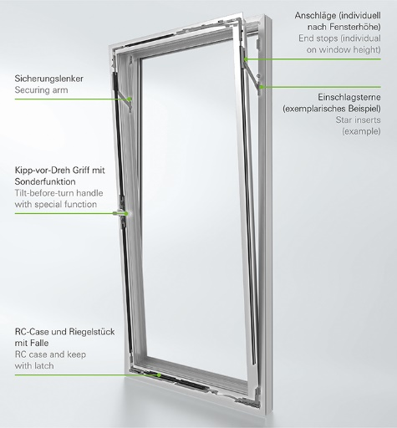
Certified security: The new fittings configuration with five security components offers burglar resistance to resistance class RC 2 even when the window is in the tilt position.

