Press release  January 2022 |  | Further information about publication:  Schüco International KG  Ulrike Krüger  Karolinenstr. 1–15  33609 Bielefeld, Germany  Tel.: +49 (0)521 783-803  Fax: +49 (0)521 783-950803  E-mail: PR@schueco.com  www.schueco.de/presse  www.schueco.com/press

Innovative robot technology for metal fabrication

Schüco RX LOAD 500

Bielefeld. Schüco RX LOAD 500 is a robot cell consisting of the new KUKA Quantec robot technology and the Schüco AF 500 CNC machine. In partnership with KUKA AG, a leading supplier of robotics and automation solutions, a robot cell has been developed which provides autonomous loading and unloading, complementing the Schüco CNC machine by increasing precision, speed and dynamism. With the RX LOAD 500 robot cell, Schüco is combatting demographic change and the shortage of skilled workers in the metal fabrication industry, in order to ensure efficient fabrication and high quality in the long term.

Schüco RX LOAD 500 offers autonomous loading and unloading, fully automated cutting and controlled processing of profiles. The robot is positioned behind the Schüco AF 500 five-axis CNC machine, moving along a linear axis with a maximum speed of 200 metres per minute. In front of the machine is a moveable rack with space for up to 24 bars for storing profiles and finished components. The Schüco SchüCAM control software is used to generate a loading list for the rack, which specifies where the employee should place each profile. The robot uses its gripper, which can bear loads of up to 36 kilogrammes, to take the profiles from the rack and load the machine. Following automatic cutting and processing by the Schüco AF 500 CNC machine, the cut profiles are unloaded and stored in the rack. The robot takes up a minimal amount of space and can also be retrofitted to an existing Schüco AF 500 CNC machine. The integrated control unit for the machine is already equipped with the module required for the robot cell; only the SINUMERIK Run MyRobot application software needs to be installed. An additional, space-saving safety fence ensures risk-free automatic operation. You can also switch between manual and automatic operation at any time.

Efficient fabrication with high quality
With Schüco RX LOAD 500, Schüco is combatting demographic change with an ageing workforce and the shortage of skilled workers in the metal fabrication industry. The robot cell takes care of physically demanding, time-consuming tasks that employees would otherwise do. Schüco RX LOAD 500 therefore makes work easier while optimising and speeding up the fabrication process. Delays in production can therefore be overcome and all processes harmonised. Freed-up capacity allows workers to focus on complex, quality-assurance tasks such as installation.

For more information, visit www.schueco.de/rx-load-500-en.

70 years of Schüco – System solutions for windows, doors and façades
Based in Bielefeld, the Schüco Group develops and sells system solutions for windows, doors and façades. With 5650 employees worldwide, the company strives to be the industry leader in terms of technology and service both now and in the future. In addition to innovative products for residential and commercial buildings, the building envelope specialist offers consultation and digital solutions for all phases of a building project – from the initial idea through to design, fabrication and installation. Schüco works with 12,000 architectural practices, fabricators and construction professionals who commission buildings around the world. Founded in 1951, the company is now active in more than 80 countries and achieved a turnover of 1.695 billion euros in 2020. For more information, visit www.schueco.com

High-resolution pictures are available to download in the Schüco Newsroom at www.schueco.com/press

Picture credits: Schüco International KG
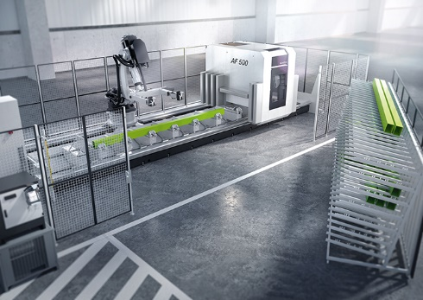
Schüco RX LOAD 500 is a robot cell that consists of the Schüco AF 500 CNC machine and a robot with a linear moving unit, safety fence and mobile rack for storing profiles.

Picture credits: Schüco International KG
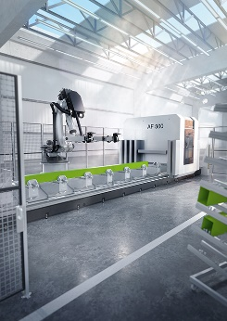
The robot technology is perfectly tailored to the Schüco AF 500 machine, optimising the fabrication process for fast, efficient and high-quality fabrication.

