Press release
8. September.2021

Aims to achieve INR 1000 crore annual revenues from Indian operations
Schüco International KG acquires majority share in Alufit International Private Limited

Bielefeld, Germany; Bengaluru, India, September 8, 2021 –
Schüco International KG, one of the leading companies in building envelopes worldwide, with global expertise in windows, doors and façades announced it has signed a definitive agreement to acquire a majority stake in Alufit. The consequent joint venture, Alufit International Pvt. Ltd, will accelerate Schüco’s focus on pursuing large commercial and infrastructure facade projects in India. The joint venture will witness the coming together of one of the world’s leading aluminium systems specialists in Schüco and India’s largest aluminium façade fabricator. Pankaj Keswani will continue to lead and will be the Managing Director of the JV, Alufit International Pvt. Ltd.

Commenting on the announcement, Andreas Engelhardt, CEO and Managing Partner of Schüco International KG, said, "India is one of the most active markets for commercial and infrastructure development in the world. As such, it is naturally a key market for Schüco as we aim to grow our presence in international markets. Our joint venture with Alufit gives us a strong platform to scale our growth in India. With a keen focus on quality and state of the art manufacturing facilities, Alufit is a perfect partner for us in delivering sustainable solutions to large façade projects in India. We will work towards enabling sustainable buildings of the future that are backed by technologies and systems that focus on people and which are in harmony with nature. We would like to congratulate all the employees of Alufit and Schüco on this partnership. We are confident that this joint venture will mutually benefit both companies and we look forward to an exciting journey together."
Pankaj Keswani, Managing Director, Alufit International Pvt. Ltd, added, “This is an important milestone for the entire Alufit family that has worked diligently towards establishing it as India’s go-to façade fabricator. Over the past three plus decades, Alufit has delivered more than 1000 projects of various size, scale and complexity with unwavering quality and professionalism. We are excited to partner with Schüco in offering developers and investors with solutions that will push the boundaries of innovation, service, and raise the bar for building envelops in India.”

Founded in 1984, Alufit has witnessed and played an integral role in evolving India’s skyline. The company has grown sustainably and earned its employees as well as customers trust. Alufit has transformed from its humble origins as an eight-member team to being a revered company for executing challenging projects from office complexes to IT parks to airports. With three state-of-the-art manufacturing facilities strategically located in Bengaluru, Hosur, and Mumbai, the
company has completed landmark projects including hospitality, World Trade Centers, IT parks and ITES campuses across the length and breadth of the country for developers, corporates and financial institutions.

As Schüco India celebrates 10 years, it will continue to focus and grow its existing business model under the leadership of Shyam Raghunandan, Managing Director, Schüco India. Schüco India develops and sells system solutions for windows, doors, façades, sliding systems, security technology and sun shading. In addition to these innovative products, the building envelop specialist offers consultation and digital solutions for all phases of a building project – from the initial idea through to design, fabrication and installation. He added, “The joint venture with Alufit will benefit existing fabricator partners of Schüco by accelerating its innovation roadmap through best-practice and knowledge transfer through its combined expertise.”

About Schüco International KG

70 years of Schüco – System solutions for windows, doors and façades
Based in Bielefeld, the Schüco Group develops and sells system solutions for windows, doors and façades. With 5650 employees worldwide, the company strives to be the industry leader in terms of technology and service both now and in the future. In addition to innovative products for residential and commercial buildings, the building envelope specialist offers consultation and digital solutions for all phases of a building project – from the initial idea through to design, fabrication and installation. Schüco works with 10,000 fabricators and 30,000 architectural practices, as well as construction professionals who commission buildings around the world. Founded in 1951, the company is now active in more than 80 countries and achieved a turnover of 1.695 billion euros in 2020. For more information, visit www.schueco.com

About Alufit International Pvt. Ltd.

Alufit is India’s leading facade fabricator. With over 1500 dedicated employees and 3 state-of-the-art facilities, Alufit is known for executing complex, large commercial and infrastructure projects across the country. Headquartered in Bangalore with additional manufacturing facilities in Hosur and Mumbai, the company has completed more than 1000 projects to attain an unparalleled reputation for its design, supply, installation and work ethic. For more information, visit www.alufit.com

Further information about publication:
Edelman India Pvt Ltd.
Santosh Castelino
Email: Santosh.castelino@edelman.com
Mobile: +91 7506549290

High-resolution pictures are available to download in the Schüco Newsroom at www.schueco.com/press

Photographer: Frank Peterschröder
Usage rights: Schüco International KG
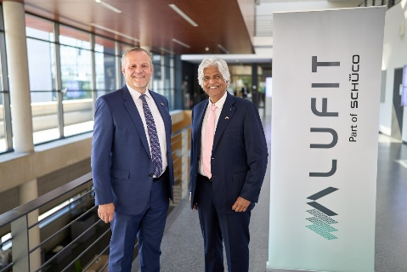
From left: Andreas Engelhardt, CEO and Managing Partner of Schüco International KG and Pankaj Keswani, Managing Director,
Alufit International Pvt. Ltd.

