Press release  February 2020 |  | Further information about publication:  Schüco International KG  Ulrike Krüger  Karolinenstr. 1–15  33609 Bielefeld, Germany  Tel.: +49 (0)521 783-803  E-mail: pr@schueco.com  www.schueco.de/presse  www.schueco.com/press

Tool for customer consulting and sales support
Schüco Product Configurator

Purchasing decisions are often easier to make if customers can take a close look at a product. Using the new Schüco Product Configurator (SPC) metal fabrication companies can individually configure Schüco windows and sliding doors in a wide range of opening options according to the client's demands in just a few minutes. Quotations can be created instantly thanks to the integration of the SchüCal calculation software.

The Schüco Product Configurator is the digital extension to the showroom. Together with the customer, all relevant data for a unit can be collected, from geometry and design to operation as well as comfort and safety accessories. Stored graphics and videos can be used to explain specifications for areas such as security, living comfort or energy efficiency. As soon as all the data has been entered, the Schüco units are depicted in realistic surroundings. The client can immediately see the appearance of the configured solution, the benefits provided by further accessories and a breakdown of the price.

The Schüco Product Configurator can be used easily, quickly and intuitively whenever you are consulting with customers and for sales support, and can also be controlled using a tablet. A technical check runs in the background thanks to the integration of the SchüCal calculation software. During each configuration step, SchüCal runs background calculations of the current price and thermal insulation value as well as the technical feasibility of the units. An individual quotation can be created at the touch of a button immediately after the consultation, providing planning security and transparency for both parties.

The Schüco Product Configurator is currently available in eight languages and consists of a hardware and software package available to lease.

For more information, visit www.schueco.com/spc

Schüco – System solutions for windows, doors and façades
Based in Bielefeld, the Schüco Group develops and sells system solutions for windows, doors and façades. With 5400 employees worldwide, the company strives to be the industry leader in terms of technology and service today and in the future. In addition to innovative products for residential and commercial buildings, the building envelope specialist offers consultation and digital solutions for all phases of a building project – from the initial idea through to design, fabrication and installation. 12,000 fabricators, developers, architects and investors around the world work together with Schüco. The company is active in more than 80 countries and achieved a turnover of 1.670 billion euros in 2018. For more information, visit www.schueco.com

High-resolution pictures are available to download
in the Schüco Newsroom at www.schueco.com/press.

Picture credits: Schüco International KG
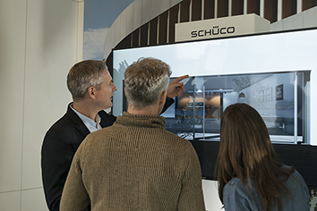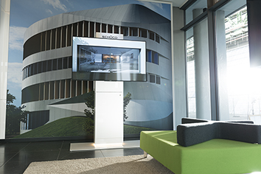
The Schüco Product Configurator illustrates the Schüco product portfolio for clients as a personalised system solution.

