Press release  January 2020 |  | Further information about publication:  Schüco International KG  Ulrike Krüger  Karolinenstr. 1–15  33609 Bielefeld  Tel.: +49 (0)521 783-803  Fax: +49 (0)521 783-950803  E-mail: PR@schueco.com  www.schueco.de/presse  www.schueco.com/press

Villa NafplioBlu, Tolo (Greece)

The coastal landscape as the shining star

Bielefeld. In the Greek town of Tolo nestled among the Peloponnese mountains and with a view of the Argolic Gulf lies Villa NafplioBlu, both the private summer residence of the client and a luxury holiday rental. In her architectural concept, Athens-based architect Katerina Valsamaki emphasised the importance of carefully integrating the building into the natural environment and having an “open dialogue” with the panoramic coastal views. Generous light openings, constructed with window and sliding systems from Schüco, allow the natural surroundings to be experienced throughout the house.

Tolo is a fishing, seaside and tourist location situated in the Peloponnese mountains, approximately 10 km south-east of Nafplio, the first capital of Greece. The plot of Villa NafplioBlu is located on the hillside above the town, surrounded by olive groves. This picturesque, exposed location permits spectacular panoramic views of the Argolic Gulf with its offshore islands of Plateia, Psili and Spetses.

Architecture follows nature
The location of Villa NafplioBlu gains even more importance in conjunction with the stylistic concept created by Katerina Valsamaki Architects (see also separate interview). In her concept, the architect accords a great deal of importance to the dialogue between the building and its environment. The position and natural surroundings of the plot in Tolo gave her the opportunity to meet this objective in full. The building is therefore nestled in the natural slope of the hillside, with some sections even built directly into the rock. In order to provide the best possible visibility of the sea views for the residents in all of the main usage zones, the rectangular building structure is arranged square to the hillside and flows into a wide open, elongated glass façade facing the sea, with a swimming pool running in parallel to almost the full length of the ground floor. Generous, open-plan living and eating areas are located here and, depending on the weather conditions and the comfort needs of the residents, there is a flexible choice between a Mediterranean outdoor living lifestyle and a transparent room division.

Nine metre-wide sliding system
In order to draw nature into the building, to dissolve the boundaries between inside and outside and to allow the panoramic views to be enjoyed all year round, the architect designed this 9 metre-wide light opening facing the sea, which was constructed using the Schüco ASS 50 sliding system. Due to the outstanding structural properties of the system, it was possible for the entire width and height of the ocean side façade to be spanned using just four slimline sliding units, each measuring approximately 2.30 m x 2.90 m. The Schüco partner company Alotek SA from Lamia constructed the four-segment system to be barrier-free using guide tracks embedded in the floor, whereby each segment runs on its own track across the entire width of the light opening. This made it possible to park all four segments directly one behind the other with no offset, all outside of the field of vision of the living space. When used in this manner, an opening of 9.00 m x 2.90 m with no visible supports is created.

Other “strategic light openings”
In keeping with her stylistic principles, the architect also worked with windows and window doors elsewhere in the building façade, which she herself describes as “strategic light openings”. Hence on the upper floor, which is set back in a similar way to a stepped storey and houses two additional bedrooms and bathrooms, the panoramic view of nature is also the shining star here as well, which the architecture consistently pursues. Floor-to-ceiling, two-part Schüco ASS 50 sliding systems and an elongated Schüco AWS 70 BS.HI panoramic window provide views of the surrounding landscape and the sea in the master bedroom. In the bathroom on the ground floor, a room-height turn/tilt window (also Schüco AWS 70 BS.HI) allows the user to either marvel at the surrounding olive groves or go out into the natural environment.

Puristic materials and selected building management technology
Aluminium window, door and sliding systems from Schüco were selected not just due to their elegance and high functionality. The sealing of the rooms and year-round energy efficiency were also deciding factors that were taken into account when opting for insulating glass with a sun shading coating. The architect also found the aluminium systems to be simply the best solution in terms of long-term care and maintenance, especially given the proximity of the building to the coast, where the frame materials and all exposed components are subjected to increased loading from a high level of UV radiation and a corrosive atmosphere.

Low-maintenance durability and understated elegance governed the choice of materials throughout Villa NafplioBlu. Stone façade units made from local natural stone, white plaster, natural stone flagstones and natural timber surfaces were selected not just because they are easy to care for but also to help integrate the building into its surroundings. The aim of these materials was to anchor the building into its natural environment. In addition to the highly insulated Schüco systems, key elements of the energy efficiency concept were a thermally-insulated façade, solar thermal panels for the provision of hot water and an automated air conditioning system for particularly hot days.

For more information about sliding door, visit
www.schueco.com/view

Project details

Project title: Villa NafplioBlu, Tolo (GR)
Use: Private holiday home and holiday rental
Architect: Katerina Valsamaki Architects, Athens (GR); www.katerinavalsamaki.gr
Metal fabricator: Alotek AE, Lamia (GR)
Completion: 2018

Schüco systems in the project

Sliding systems: Schüco ASS 50
Fixed glazing and turn/tilt window: AWS 70 BS.HI
Entrance door: Schüco ADS 65.HD
Special features:
- 9050 x 2920 mm Schüco ASS 50 sliding system, consisting of four units each with their own guide track
- Granite-coloured profiles with a sand-blasted look 'Gris 2900 Sable'
- Insulating glazing with sun shading glass on the side exposed to weathering

Schüco – System solutions for windows, doors and façades
Based in Bielefeld, the Schüco Group develops and sells system solutions for windows, doors and façades. With 5400 employees worldwide, the company strives to be the industry leader in terms of technology and service today and in the future. In addition to innovative products for residential and commercial buildings, the building envelope specialist offers consultation and digital solutions for all phases of a building project – from the initial idea through to design, fabrication and installation. 12,000 fabricators, developers, architects and investors around the world work together with Schüco. The company is active in more than 80 countries and achieved a turnover of 1.670 billion euros in 2018. For more information, visit www.schueco.com

Interview with Katerina Valsamaki, Katerina Valsamaki Architects, Athens

What signature features of your architectural practice can be seen in the architecture of Villa NafplioBlu?
Katerina Valsamaki: The main characteristic features of our designs and our architectural style are the following:
1. The appropriate positioning of the building in the landscape
2. The simplicity of the design language
3. The unification of the inside and outside spaces
4. The strategically placed light openings which allow the natural surroundings to be fully experienced by the residents
5. A choice of materials that reflects the minimalism and purism of the architecture while also being low-maintenance.
For the building in question, locally occurring natural stone, light-coloured plaster and aluminium window and door systems were used.

How do the glazed window, door and sliding systems from Schüco fit into the concept for Villa NafplioBlu?
Katerina Valsamaki: Large light openings allow the particular features of the surrounding landscape to be highlighted. Floor-to-ceiling, moveable sliding systems take this one step further by dissolving the boundary between inside and outside and intensifying the feeling of space, even when closed, thanks to the far-reaching views they permit.

What are the technical reasons behind the choice of system?
Katerina Valsamaki: The current high-quality window systems made from aluminium feature impressively slimline, elegant and almost fully concealed frame profiles – and they provide this for extremely large glass dimensions and large bridgeable spans. This creates design freedom and flexibility for our architecture. At the same time, all of the technical requirements can be configured individually and fulfilled at different levels – be it thermal insulation, security or operating comfort and automation. A further important aspect is long-term low-maintenance. For buildings near the coast, there is no better choice than high-quality aluminium frame constructions due to the increased load they are subjected to from wind, sun and corrosion.
One focus area of your practice is the construction of luxury private residences. What aspects are particularly important to these discerning clients?
Katerina Valsamaki: Quality and sustainability are just as important for all aspects of the design as for the construction. When it comes to the design and room layout, there is a preference for large open spaces which flow into one another and enable flexible use of the rooms. Clean lines and practical, durable, low-maintenance materials are part of this. Large window and door openings are equally high on the clients' list of requirements. The building also has to be integrated as well as possible into the landscape and initiate dialogue with the surroundings in terms of design and materials.

The use of modern building management systems is increasing, including in luxury newbuilds. Smart Home operating, security and monitoring systems are just as important as construction and technical measures that contribute towards increased energy efficiency. The challenge today is to integrate these diverse aspects in a smart and concealed way, networking them together conceptually and in terms of design.

High-resolution pictures are available to download in the Schüco Newsroom at www.schueco.com/press.

Picture credits: Schüco International KG // Konstantinos Thomopoulos
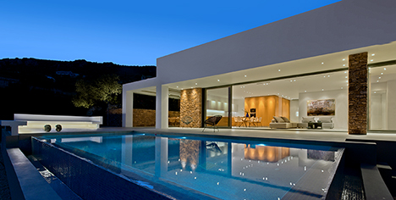
A floor-to-ceiling sliding system measuring approx. 9.00 m wide by 2.90 m high (Schüco ASS 50) provides direct access from the interior living/dining area to the pool and terrace.

Picture credits: Schüco International KG // Konstantinos Thomopoulos
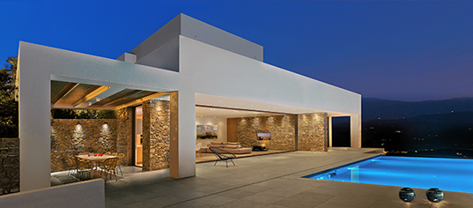
The sliding system consists of four units each with their own guide track. This creates variable openings that can be adapted to the wind and weather conditions.

Picture credits: Schüco International KG // Konstantinos Thomopoulos
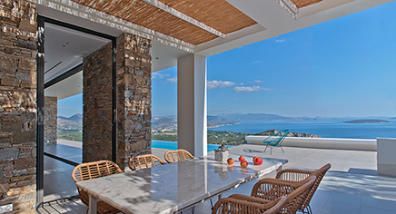
Outer dining area at the side, near to the pool (Schüco ASS 50 sliding into the natural stone wall).

Picture credits: Schüco International KG // Konstantinos Thomopoulos
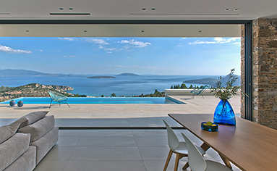
Panoramic view of Tolo Bay and the Argolic Gulf: the architecture of Villa NafplioBlu takes full advantage of the natural and topographical features of the spectacular plot.

Picture credits: Schüco International KG // Konstantinos Thomopoulos
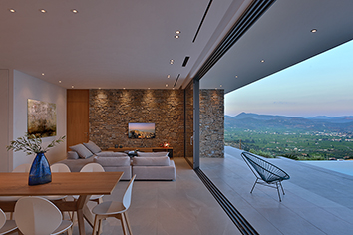
For a maximum opening of 9.00 m, all four units can be 'parked' one behind the other, outside of the field of vision in the living and dining area.

Picture credits: Schüco International KG // Konstantinos Thomopoulos
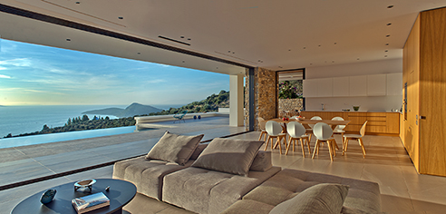
The guide tracks for the Schüco ASS 50 system are embedded in the floor at the bottom and flush-fitted into the suspended ceiling at the top.

Picture credits: Schüco International KG // Konstantinos Thomopoulos
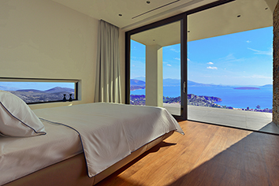
The windows in the master bedroom on the ground floor are oriented to showcase the view of the landscape: ribbon-style Schüco AWS 70 BS.HI fixed glazing (left) and a two-part Schüco ASS 50 sliding system.

Picture credits: Schüco International KG // Konstantinos Thomopoulos
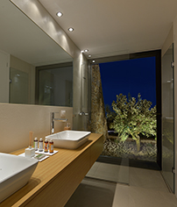
Generous views of the surrounding olive groves from the bathroom: Schüco AWS 70 BS.HI window unit with turn/tilt fittings.

Picture credit: Katerina Valsamaki Architects

Architect Katerina Valsamaki, Athens (GR)

Picture credit: Katerina Valsamaki Architects
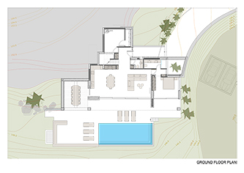
Floor plan of the ground floor / site plan

Picture credit: Katerina Valsamaki Architects
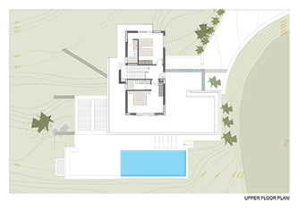
Floor plan of the first floor

Picture credit: Katerina Valsamaki Architects
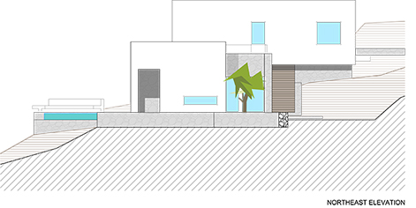
Northeast view

Picture credit: Katerina Valsamaki Architects
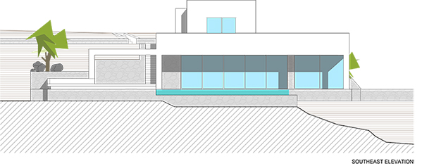
Southeast view

