Press release  June 2021 |  | Further information about publication:  Schüco International KG  Ulrike Krüger  Karolinenstr. 1–15  33609 Bielefeld, Germany  Tel.: +49 (0)521 783-803  Fax: +49 (0)521 783-950803  E-mail: PR@schueco.com  www.schueco.de/presse  www.schueco.com/press

Award-winning office building with closed-cavity façade

ToHa Tower 1, Tel Aviv

Bielefeld / Tel Aviv. ToHa Tower 1 of Totzeret HaAretz Towers in Tel Aviv, Israel, was named “Best Tall Office Building” in the world and “Best Tall Building Middle East & Africa” in mid-May by the Council on Tall Buildings and Urban Habitat (CTBUH) in Chicago. Schüco played a key role in the development and implementation of the innovative and sustainable closed-cavity façade, which enables the office building to meet the particular requirements of an Israeli major city, including comprehensive sound reduction, high energy efficiency and reduced cleaning.

The CTBUH Annual Awards program recognises projects and individuals that have made extraordinary contributions to the advancement of tall buildings and the urban environment, and that achieve sustainability at the highest and broadest level. Designed by architects Ron Arad and Avner Yashar, ToHa Tower 1 stands 110 metres tall and outclassed dozens of projects from all over the world, including China, France, New York and London, to win these awards. The unique geometry of the building was inspired by the concept of an iceberg with its irregular shapes in all directions, producing a one-of-a-kind layout in every area. By extending the floor slab of each storey beyond the plane of the building envelope, the interior is protected from direct sunlight, while natural light and fresh air enter the office spaces through an atrium that spans the full height of the building.

An innovative façade construction
Schüco played a key role in the development and implementation of the innovative façade of this award-winning building. This was possible thanks to the initiative of the employees at Schüco in Israel. The on-site team expertly coordinated the many people involved, enabling the project to be successfully completed. Professor Winfried Heusler, Senior Vice President of Global Building Excellence at Schüco, explained further: “Developing a closed-cavity façade for the Israeli climate was unchartered territory for us, and so was a real challenge. We chose to work with a local façade contractor, Aluminium Construction Ltd. (Israel), because we knew that, as a team, we had the right experience and qualifications for such a technically and logistically demanding project.”

A closed-cavity façade is a variation on the twin-wall façade, but with a completely closed chamber between the inner and outer skins. Due to its double-skin configuration, this special façade construction provides excellent sound reduction. This can be achieved without the use of special sound reduction glass, which isn't the case for other façade constructions. Cooling loads and operating costs can be reduced by means of the protected sun shading that is integrated into the cavity. This internal sun shading and the space between the façade skins is completely closed off to dirt from both the outside and inside, and therefore does not require cleaning. In addition, the closed-cavity façade features excellent energy efficiency, which is also thanks to the closed space between the façade skins. The closed cavity façade of the ToHa Tower is therefore the response to the challenges posed by an Israeli major city, where the buildings are constantly subjected to heat, noise pollution and fine sand dust particles.

To ensure the closed cavity of the façade would be able to withstand the changing temperatures in Israel and no condensation would develop, comprehensive structural calculations were initially carried out by the metal fabricator and then by an external German engineering practice, which was coordinated by the Schüco office in Tel Aviv. Factors such as the prevailing climate conditions, solar radiation and the building orientation, were all included in the calculation. Taking these calculations as a basis and using sensors installed in the cavity to constantly monitor the relative humidity and the temperature, clean, conditioned air is fed into the individual closed cavities via a centrally controlled ring circuit system as required. Every façade front and storey is monitored and controlled separately. Excess air can be guided out through a pressure-relief valve in the outer frame. This permanently ensures that the relative humidity, the temperature and the pressure in the cavity remain within the calculated limit values so that no condensation can form.

Furthermore, numerous tests had to be carried out at the ift Rosenheim (German Institute for Window Technology) to prove that the closed-cavity façade was suitable for the climate conditions in Israel.
Given the high temperatures in the space between the façade walls, the “fogging tests” performed on the materials used also played a vital role. For the fogging tests, all of the materials that were to be installed in the closed cavity were subjected to high temperatures in advance, to identify any potential degasification of the materials at an early stage. This degasification could lead to condensation forming in the space between the façade skins. Only materials that displayed no degasification, even at high temperatures, could then be used in the closed-cavity façade. Seasonal temperature fluctuations and solar radiation in particular affect both the dew point and the pressure in the closed cavity. If the air in the cavity heats up, the cavity will expand and then contract again when the air cools.
To ensure that moisture and dirty external air cannot penetrate the closed cavity in an uncontrolled way as a result of these natural fluctuations, there is a pressure-relief valve in the outer frame of the façade. If the pressure in the cavity is too high, it can be equalised using this valve, while dry, clean air is fed in as required via the ring circuit system. A pre-defined level of positive pressure is therefore continuously maintained in the façade through the supply of clean, dry air. This system allows the cavity to remain permanently free from condensation.

70 years of Schüco – System solutions for windows, doors and façades
Based in Bielefeld, the Schüco Group develops and sells system solutions for windows, doors and façades. With 5650 employees worldwide, the company strives to be the industry leader in terms of technology and service both now and in the future. In addition to innovative products for residential and commercial buildings, the building envelope specialist offers consultation and digital solutions for all phases of a building project – from the initial idea through to design, fabrication and installation. Schüco works with 12,000 architectural practices, fabricators and construction professionals who commission buildings around the world. Founded in 1951, the company is now active in more than 80 countries and achieved a turnover of 1.695 billion euros in 2020. For more information, visit www.schueco.com
High-resolution pictures are available to download in the Schüco Newsroom at
www.schueco.com/press

Photographer: Sharon Tzarfati Photography
Usage rights: Schüco International KG
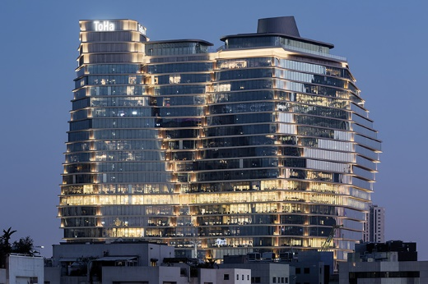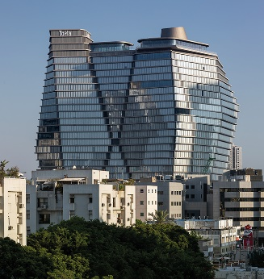
ToHa Business Tower 1 was named “Best Tall Office Building” in the world and “Best Tall Building Middle East & Africa” in mid-May by the Council on Tall Buildings and Urban Habitat (CTBUH).

Photographer: Sharon Tzarfati Photography
Usage rights: Schüco International KG
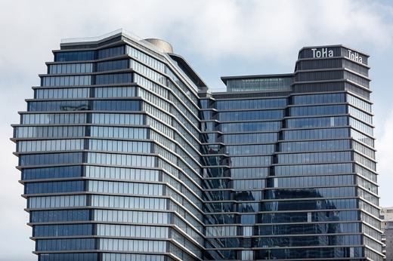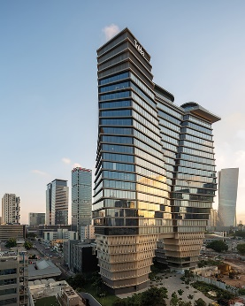
Schüco played a key role in the development and implementation of the innovative closed-cavity façade of this award-winning building.

Photographer: Sharon Tzarfati Photography
Usage rights: Schüco International KG
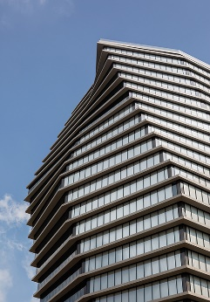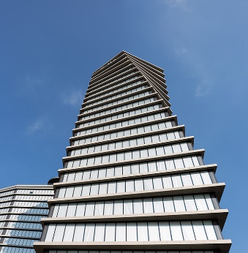
The design of ToHa Tower 1 was inspired by the unusual geometry of an iceberg.

Photographer: Frank Peterschröder
Usage rights: Schüco International KG
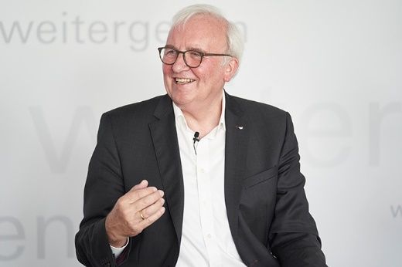
Professor Winfried Heusler, Senior Vice President of Global Building Excellence at Schüco

