Press release  May 2021 |  | Further information about publication:  Schüco International KG  Ulrike Krüger  Karolinenstr. 1–15  33609 Bielefeld, Germany  Tel.: +49 (0)521 783-803  Fax: +49 (0)521 783-950803  E-mail: PR@schueco.com  www.schueco.com/press  www.schueco.com/press

Lightweight vacuum-insulating glass

Schüco and AGC Glass Europe enter into strategic partnership

Bielefeld/Louvain-la-Neuve. Schüco is combining forces with glass specialist AGC Glass Europe with the aim of actively furthering technical expertise and synergies in the research and development of pioneering aluminium solutions using vacuum-insulating glass for the building envelope.

Ever-increasing requirements for energy-efficient buildings demand innovative, smart solutions in terms of technology, design and sustainability. Simple, reliable fabrication and installation are also hugely important to fabricators. Dr Karl Stefan Dewald, Head of the Façades business unit at Schüco, comments on the strategic partnership: "With AGC Glass Europe, we have found the perfect partner to help us meet the future requirements of the market and customers." Serge Martin, CEO FINEO® Glass, also confirms: "We are very honored by this partnership, as Schüco represents high-end premium systems and has a leadership position on the market. To embrace FINEO as an innovative product is an opportunity for both of us. We are convinced we will offer outstanding solutions to the market, which will combine high performances, sustainability and design.”

Innovative technology
According to AGC Glass Europe, the FINEO® vacuum-insulating glass technology it developed features an innovative system structure. The slimline overall construction consists of two glass panes which are separated by just one thin vacuum space between the panes measuring 0.1 millimetres. Incredibly slim overall glass thicknesses of 6 millimetres can therefore be achieved, depending on the glass dimensions and climate conditions. This means that the FINEO® vacuum-insulating glass is around one third lighter than triple insulating glass. FINEO® does not have any evacuation port – a benefit for the appearance, visibility and durability. FINEO® also boasts excellent thermal insulation properties with a U_{g} value of 0.7 W/(m²K) and improved sound insulation (traffic noise reduced by 3-7 decibels compared to double or triple glazing). A further benefit is that the light transmission is up to 20 percent higher than with triple glazing. The FINEO® vacuum-insulating glass can be fully recycled – an important factor when it comes to the construction of future-proof buildings.

For more information about AGC Glass, visit www.agc-glass.eu, www.agc-yourglass.com and www.fineoglass.eu.

For more information about Schüco, visit www.schueco.com and www.schueco.de/inow.

AGC Glass Europe, a European leader in flat glass
Based in Louvain-la-Neuve (Belgium), AGC Glass Europe produces, processes and markets flat glass for the construction industry (external glazing and interior decoration), car manufacture and industrial sectors (transport, energy and high-tech). It is the European branch of AGC, the world’s leading producer of flat glass. It has over 100 sites throughout Europe, from Spain to Russia, and employs around 16,000 employees. For more information, visit www.agc-glass.eu, www.agc-yourglass.com or www.fineoglass.eu.
70 years of Schüco – System solutions for windows, doors and façades
Based in Bielefeld, the Schüco Group develops and sells system solutions for windows, doors and façades. With 5650 employees worldwide, the company strives to be the industry leader in terms of technology and service both now and in the future. In addition to innovative products for residential and commercial buildings, the building envelope specialist offers consultation and digital solutions for all phases of a building project – from the initial idea through to design, fabrication and installation. Schüco works with 12,000 architectural practices, fabricators and construction professionals who commission buildings around the world. Founded in 1951, the company is now active in more than 80 countries and achieved a turnover of 1.750 billion euros in 2019. For more information, visit www.schueco.com

High-resolution pictures are available to download in the Schüco Newsroom at www.schueco.com/press

Picture credits: Schüco International KG
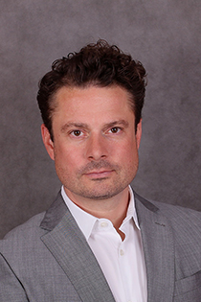
Dr Karl Stefan Dewald, Head of Business Unit Façade at Schüco.

Picture credits: AGC Glass Europe
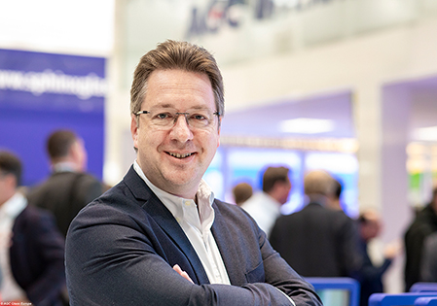
Serge Martin, CEO FINEO® Glass.

Picture credits: Schüco International KG
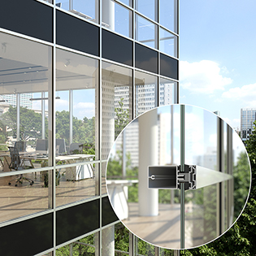
A glimpse of the future: Schüco façades with vacuum-insulating glass technology from AGC.

