Press release  February 2021 |  | Further information about publication:  Schüco International KG  Ulrike Krüger  Karolinenstr. 1–15  33609 Bielefeld, Germany  Tel.: +49 (0)521 783-803  Fax: +49 (0)521 783-950803  E-mail: PR@schueco.com  www.schueco.com/press  www.schueco.com/press

Window handles, door handles and aluminium profile surfaces

Schüco SmartActive antimicrobial surface finish

Bielefeld. SmartActive, the long-lasting surface coating for Schüco window, door and sliding door handles as well as profile surfaces, reduces the transfer of germs like bacteria, viruses, fungi and yeasts. This is particularly important as a measure to aid disinfection in public buildings with a large number of people. The microsilver used is free of nano particles and cannot penetrate human skin.

High hygiene standards are incredibly important in hospitals, care homes, nurseries and public buildings – especially in this day and age. Operating units like window and door handles as well as the associated window and door profile surfaces can harbour germs over an extended period of time after being touched by contaminated people, passing on infections to others. Multi-resistant germs which no longer respond to treatment with antibiotics are primarily found in hospitals and nursing homes.

With SmartActive, the company offers an antimicrobial surface coating for Schüco window, door and sliding door handles and for the interior profile surfaces of window, door, sliding and façade systems. The microsilver particles embedded in the surface (Micro Silver BGTM) effectively prevent germs from multiplying. Independent lab tests have shown a reduction in germs of at least 99.9% within 24 hours, proven for MRSA and E.coli bacteria. The high-purity microsilver used is purely metallic, nano-free and therefore cannot penetrate human skin. It is safe for humans and the environment, is used in medical products and is even certified for natural cosmetics. The SmartActive antimicrobial surface finish, which helps to provide long-lasting disinfection, can significantly reduce germs between cleaning cycles.

Depending on the article, the antimicrobial handle range is available in the surface finishes anodised C0, stainless steel look, silver look (powder coating) or as a special order with powder coating in other colours. Profile surfaces are exclusively available with powder coating. A wide range of colours ensures a high level of design freedom. The fabrication process for standard surfaces, window and door handles is the same as conventional Schüco metal systems.

For more information, visit www.schueco.de/smartactive-en and the HEALTH section at www.schueco.de/inow-en.

70 years of Schüco – System solutions for windows, doors and façades
Based in Bielefeld, the Schüco Group develops and sells system solutions for windows, doors and façades. With 5650 employees worldwide, the company strives to be the industry leader in terms of technology and service today and in the future. In addition to innovative products for residential and commercial buildings, the building envelope specialist offers consultation and digital solutions for all phases of a building project – from the initial idea through to design, fabrication and installation. 12,000 fabricators, developers, architects and investors around the world work together with Schüco. Founded in 1951, the company is today active in more than 80 countries and achieved a turnover of 1.750 billion euros in 2019. For more information, visit www.schueco.com

High-resolution pictures are available to download in the Schüco Newsroom at www.schueco.com/press

Picture credits: Schüco International KG
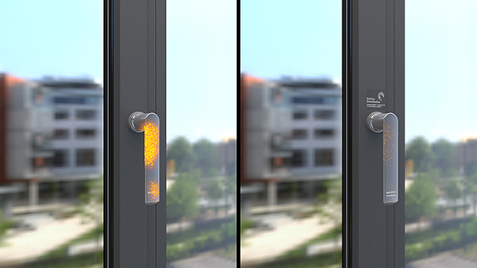
Visualisation of Schüco SmartActive: The microsilver particles embedded in the surface (Micro Silver BGTM) effectively prevent germs from multiplying on Schüco window, door and sliding door handles and profile surfaces. Independent lab tests have shown a reduction in germs of at least 99.9% within 24 hours, proven for MRSA and E.coli bacteria.

Picture credits: Schüco International KG

SmartActive, the long-lasting surface coating for Schüco window, door and sliding door handles as well as profile surfaces, reduces the transfer of germs like bacteria, viruses, fungi and yeasts. This is particularly important as a measure to aid disinfection in public buildings with a large number of people.

