Press release  January 2021 |  | Further information about publication:  Schüco International KG  Ulrike Krüger  Karolinenstr. 1–15  33609 Bielefeld, Germany  Tel.: +49 (0)521 783-803  Fax: +49 (0)521 783-950803  E-mail: PR@schueco.com  www.schueco.de/presse  www.schueco.com/press

Schüco AWS 90 AC.SI acoustic window

Sound reduction and natural window ventilation

Bielefeld. Environmental noise is growing in significance for public health, as asserted by the WHO in their guidelines. Noise pollution in cities is increasing with the rising density of traffic. At the same time, the need for housing in integrated urban areas is also increasing. That is why improved measures for the suppression and dissipation of noise are increasingly coming to the fore where the planning of new buildings in urban spaces is concerned. The desire for natural ventilation, however, stands in opposition to this. With the Schüco AWS 90 AC.SI acoustic window, the company is launching a new single-skin window solution, which combines sound reduction and natural ventilation when tilted. The system is available now.

The new Schüco AWS 90 AC.SI (Aluminium Window System, 90 mm basic depth, Acoustics, Super Insulated) acoustic window offers a high level of user comfort, particularly for residential and office buildings in areas with high levels of noise. In the sound reduction tilt position, incoming external air is fed through pre-fabricated ventilation cassettes in the top outer frame. In this way, the sound dissipates and noise pollution is markedly reduced. This allows sound reduction of 31 dB to be achieved as well as natural ventilation. There is the turn/tilt window version and the side-hung / side-hung window version with two opening positions. The side-hung / side-hung window can be moved into the restricted turn position for soundproofed ventilation. It can also be fully opened.

The turn/tilt window can also be opened fully via the turn/tilt fitting for quick cross ventilation or cleaning of the outer glass pane from the inside. The ventilation cassettes can also be opened and cleaned or completely replaced quickly and easily through the window rebate space.

The Schüco AWS 90 AC.SI acoustic window completes the company's existing product range for reducing noise through the building envelope. The product range already includes tailored composite window, box window and acoustic window special solutions which can be used to achieve both sound reduction requirements and natural ventilation. www.schueco.de/acoustic-window

70 years of Schüco – System solutions for windows, doors and façades
Based in Bielefeld, the Schüco Group develops and sells system solutions for windows, doors and façades. With 5650 employees worldwide, the company strives to be the industry leader in terms of technology and service today and in the future. In addition to innovative products for residential and commercial buildings, the building envelope specialist offers consultation and digital solutions for all phases of a building project – from the initial idea through to design, fabrication and installation. 12,000 fabricators, developers, architects and investors around the world work together with Schüco. Founded in 1951, the company is today active in more than 80 countries and achieved a turnover of 1.750 billion euros in 2019. For more information, visit www.schueco.com

Picture credits: Schüco International KG

High-resolution pictures are available to download in the Schüco Newsroom at www.schueco.com/press.

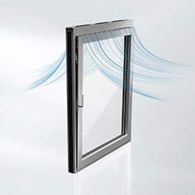
The new Schüco AWS 90 AC.SI acoustic window allows sound reduction of 31 dB to be achieved in the tilt position.

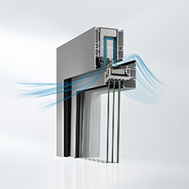
In the sound reduction tilt position, incoming external air is fed through pre-fabricated ventilation cassettes installed in the top outer frame of the Schüco AWS 90 AC.SI acoustic window. This dissipates the sound.

