Press release  October 2020 |  | Further information about publication:  Schüco International KG  Ulrike Krüger  Karolinenstr. 1–15  33609 Bielefeld, Germany  Tel.: +49 (0)521 783-803  Fax: +49 (0)521 783-950803  E-mail: PR@schueco.com  www.schueco.de/presse  www.schueco.com/press

Schüco car park with FACID textile façade:

Form meets function

Bielefeld. The Schüco FACID textile façade with sophisticated system technology offers functional design freedom with practical benefits. The façade can be adapted and shaped to fit a wide variety of supporting surfaces. This results in unique designs that can be quickly implemented in a cost-effective way, even when the building is in use, thanks to the use of system profiles. One example of this is the new car park on the Schüco Campus in Bielefeld.

The impressive design of the car park immediately catches your eye. The FACID fabric wraps around the simple cubic construction of the car park like a shimmering cocoon. The load-bearing structure of the building consists of a substructure made from steel and aluminium, giving the envelope its three-dimensional shape. A total of 2949 square metres of textile façade cover the 18 metre-high eight-storey car park. A patented clamping system using flexholder technology ensures that the fabric is pulled tightly into all of the corners without any creases.
The most unique feature of the FACID façade lies in how the 3D effect is implemented. The ability to shape the individual sections separately creates surfaces that can be constructed in two and three dimensions.
And that's not all: FACID can be individually printed and illuminated – there are practically no limits to the extraordinary designs that are possible. This illumination has also been used in the Schüco car park: by day, the parking levels are bright and flooded with light, with the transparent fabric allowing excellent ventilation and unrestricted views from inside to outside. As soon as it's dark, accentuated illumination of the façade and motion-activated interior lighting create imaginative light effects.
Furthermore, FACID provides effective weathering and glare protection, as well as sun shading, and therefore contributes to heat reduction in buildings. The specially coated fabric also provides certified fire protection, which is especially important for the cladding of steel structures. A fibreglass fabric with Teflon coating in fire protection class A2 was used for the Schüco car park.

The project in Bielefeld was implemented by SCHLATTMEIER ARCHITEKTEN, working in partnership with 3XN on the façade design. Karsten Schlattmeier was particularly impressed by the effect of depth created by FACID, saying: "While glass walls, for example, can appear restrictive, a tensioned textile façade in front of the structure creates a feeling of depth for the observer. The result is a translucent appearance with the structure behind the façade remaining visible."

Facts and figures about the Schüco car park:
Floor area: 2665 m²
Overall size: 21,319 m²
Height: 18 m
Levels: 8
Parking spaces: 732
Spaces for electric cars: 12
Completion: 2019
Period of construction: 1 year

Installation time for two FACID façades: 8 weeks
Material: fibreglass fabric with Teflon coating
Fire protection class A2
Façade surface area in m²: three sides with a 3D façade totalling 2179 m², one side with a 2D façade (rear side) totalling 770 m²

Involved in the project:
Schüco Campus master plan: 3XN
Architecture: SCHLATTMEIER ARCHITEKTEN, Herford
Construction of the car park: GOLDBECK Nord GmbH, Bielefeld
Construction of the FACID façade: Hillebrandt Stahl- und Behälterbau GmbH, Greven.

For more information, visit www.schueco.com/facid.
Schüco – System solutions for windows, doors and façades
Based in Bielefeld, the Schüco Group develops and sells system solutions for windows, doors and façades. With 5650 employees worldwide, the company strives to be the industry leader in terms of technology and service today and in the future. In addition to innovative products for residential and commercial buildings, the building envelope specialist offers consultation and digital solutions for all phases of a building project – from the initial idea through to design, fabrication and installation. 12,000 fabricators, developers, architects and investors around the world work together with Schüco. The company is active in more than 80 countries and achieved a turnover of 1.750 billion euros in 2019. For more information, visit www.schueco.com

High-resolution pictures are available to download in the Schüco Newsroom at www.schueco.com/press.

Picture credits: SCHLATTMEIER ARCHITEKTEN
Façade design in collaboration with 3XN
Photographer: Christian Eblenkamp
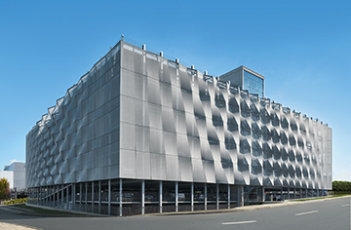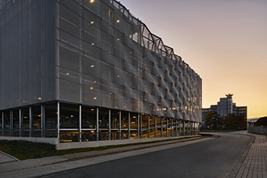
The FACID fabric wraps around the simple cubic construction of the Schüco car park like a shimmering cocoon.

Picture credits: SCHLATTMEIER ARCHITEKTEN
Façade design in collaboration with 3XN
Photographer: Christian Eblenkamp
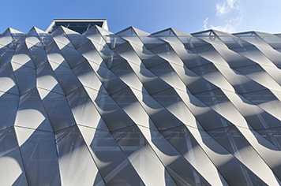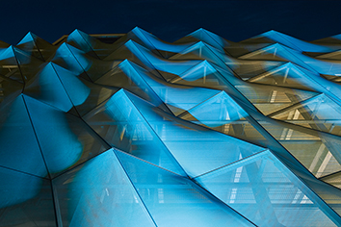
The most unique feature of the FACID façade of the Schüco car park lies in how the 3D effect is implemented. The ability to shape the individual sections separately creates surfaces that can be constructed in two and three dimensions.

Picture credits: SCHLATTMEIER ARCHITEKTEN
Façade design in collaboration with 3XN
Photographer: Christian Eblenkamp
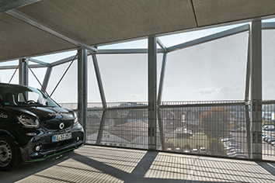
By day, the parking levels are bright and flooded with light, with the transparent fabric allowing excellent ventilation and unrestricted views from inside to outside.

Picture credits: SCHLATTMEIER ARCHITEKTEN
Façade design in collaboration with 3XN
Photographer: Christian Eblenkamp
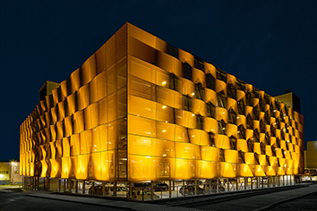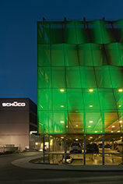
As soon as it's dark, accentuated illumination of the façade and motion-activated interior lighting create imaginative light effects.

